WEEK 1: UNDERSTANDING THE BUSINESS CONTEXT: EXTERNAL AND COMPETITVE ENVIRONMENTS:
CONTEXT: The interrelated conditions in which something exist. The environment

ANALYSING THE BUSINESS ENVIRONMENT:
ANALYSING THE MACRO-BUSINESS ENVIRONMENT:
P.E.S.T analysis:
-POLITICAL FACTORS: local and national
Taxation, legislation, regulations, unions
-ECONOMICAL FACTORS
Interest and exchange rates, NZ economy, GDP rate, growth, unemployment…
-TECHNOLOGICAL FACTORS
Diverse pop. Aging pop. Social class, lifestyles…. (wants and needs)
-SOCIAL-CUTURAL FACTORS
ICT, fast uptake, rapid growth, competitor and consumer use.

Model helps determine market strategy.

Basically we are looking for trends in the overall environment which will either impact our business either positively or negatively. Their importance varies according to the business we are in and the market we serve.
Analysing these allows for us to see identify future opportunities that we might take advantage of as well as threats that could hinder us.

INFORMATION: How do we ensure our strategies are on target?
1. Analyse these trends in the context of your business
2. Identify opportunities and threats
3. Develop strategies around them and your micro and internal analysis to achieve your objectives.
Top brands fail to accept the signs from trends and fail, e.g. Blockbuster vs. Netflix takeover. Global dinosaurs cannot adapt and feel they have a divine right over their product e.g Kodak. Patents quickly EXPIRE, so companies need to look into the future aided by trends.

PORTER’S 5 FORCES:
Used to analyse a specific industry and to see whether new products, services or businesses have the potential to succeed and the balance of power in an industry and can be used to analyse any type of business opportunity. The
extended rivalry that results from all ﬁve forces deﬁnes an industry’s structure and shapes the nature of competitive interaction within an industry.
If the forces are intense, as they are in such industries as airlines, textiles, and hotels, almost no company earns attractive returns on investment. If the forces are benign, as they are in industries such as software, soft drinks, and toiletries, many companies are proﬁtable. Industry structure drives competition and proﬁtability, not whether
an industry produces a product or service, is emerging or mature, high tech or low tech, regulated or unregulated. While a myriad of factors can affect industry proﬁtability in the short run – including the weather and the business cycle – industry structure, manifested in the competitive forces, sets industry proﬁtability in the medium and long run. Understanding the competitive forces, and their underlying causes, reveals the roots of an industry’s current proﬁtability while providing a framework for anticipating and inﬂuencing competition (and proﬁtability) over time.
The strongest competitive force or forces determine the proﬁtability of an industry and become the most important
to strategy formulation. INDUSTRY STRUCTURE DRIVES COMPETITION AND PROﬁTABILITY, NOT WHETHER AN INDUSTRY IS EMERGING OR MATURE, HIGH TECH OR LOW TECH, REGULATED OR UNREGULATED.

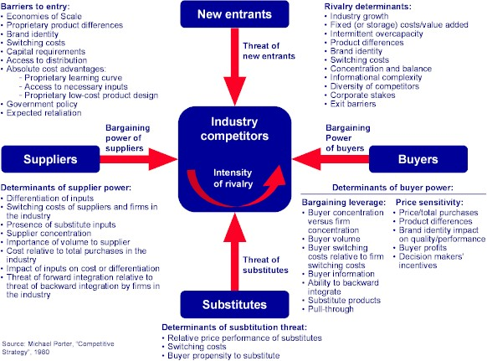
If BARRIERS OF ENTRY: HIGH, brand awareness and loyalty, dynamic environment vulnerable to high fuel costs and recessions, big marketing and advertising budgets are required. Trying to compete on price alone means having to reduce the quality of service for passengers. Customer switching costs, the larger the switching costs, the harder it will be for an entrant to gain customers. Enterprise resource planning (ERP) software is an example of a product with very high switching costs. Capital requirements: The need to invest large ﬁnancial resources in order to compete can deter new entrants. No matter what their size, incumbents may have cost or quality advantages not available to potential rivals. These advantages can stem from such sources as proprietary technology, preferential access to the best raw material sources, pre-emption of the most favourable geographic locations, established brand identities, or cumulative experience that has allowed incumbents to learn how to produce more efﬁciently. Restrictive government policy, unequal access to distribution channels.
TRADE-OFFS: do they exist?
Supply-side scale economies deter entry by forcing the aspiring entrant either to come into the industry on a large scale, which requires dislodging entrenched competitors, or to accept a cost disadvantage.
Buyers may trust larger companies more for a crucial product: Recall the old adage that no one ever got ﬁ red for buying from IBM (when it was the dominant computer maker). Buyers may also value being in a “network” with a larger number of fellow customers. Demand-side beneﬁts of scale discourage entry by limiting the willingness of customers to buy from a newcomer and by reducing the price the newcomer can command until it builds up a large base of customers.
How potential entrants believe incumbents may react will also inﬂuence their decision to enter or stay out of an industry. If reaction is vigorous and protracted enough, the proﬁt potential of participating in the industry can fall below the cost of capital. Incumbents often use public statements and responses to one entrant to send a message to other prospective entrants about their commitment to defending market share.
Newcomers are likely to fear expected retaliation if: Incumbents have previously responded vigorously to new entrants.
Incumbents possess substantial resources to ﬁght back, including excess cash and unused borrowing power, avail-
-able productive capacity, or clout with distribution channels and customers.
Incumbents seem likely to cut prices because they are committed to retaining market share at all costs or because the industry has high ﬁxed costs, which create a strong motivation to drop prices to ﬁll excess capacity. Industry growth is slow so newcomers can gain volume only by taking it from incumbents.
An analysis of barriers to entry and expected retaliation is obviously crucial for any company contemplating entry into
a new industry. The challenge is to ﬁnd ways to surmount the entry barriers without nullifying, through heavy investment, the proﬁtability of participating in the industry.

THREAT OF NEW ENTRANTS: LOW, high investment costs, difficult to raise capital (borrowing money) , price “wars” hurt profits however existing players “ride out the storm” and overcome new entrants.
RIVALRY: competitors can come to a mutual agreement code sharing

THE POWER OF SUPPLIERS: Powerful suppliers capture more of the value for themselves by charging higher prices,
limiting quality or services, or shifting costs to industry participants. Powerful suppliers, including suppliers of labour, can squeeze proﬁtability out of an industry that is unable to pass on cost increases in its own prices. The supplier group does not depend heavily on the industry for its revenues. If a particular industry accounts for a large portion of a supplier group’s volume or proﬁt, however, suppliers will want to protect the industry through reasonable pricing and assist in activities such as R&D and lobbying. Switching costs: When switching costs are high, industry participants ﬁnd it
hard to play suppliers off against one another. (Note that suppliers may have switching costs as well. This limits their power.) Suppliers offer products that are differentiated. Limited substitutes give suppliers power over the company.

THE POWER OF BUYERS. Powerful customers can capture more value by forcing down prices, demanding better quality or more service (thereby driving up costs), and generally playing industry
participants off against one another, all at the expense of industry proﬁtability. Buyers are powerful if they have negotiating leverage relative to industry participants, especially if they are price sensitive, using their clout primarily to pressure price reductions.
As with suppliers, there may be distinct groups of customers who differ in bargaining power. A customer group has
negotiating leverage if:
There are few buyers, or each one purchases in volumes that are large relative to the size of a single vendor. Large volume buyers are particularly powerful in industries with high ﬁxed costs, such as telecommunications equipment, offshore drilling, and bulk chemicals. High fixed costs and low marginal costs amplify the pressure on rivals to keep capacity ﬁlled through discounting. The industry’s products are standardized or undifferentiated. If buyers believe they can always ﬁnd an equivalent product, they tend to play one vendor against another.

AIR NEW ZEALAND: Understood and took action towards the changes going on in their environment and decided to take the risk of leading in business innovation rather than following others.

