WEEK 10- WORKFORCE MANAGEMENT:
WORKFORCE MANAGEMENT IS CRITICAL TO DETERMINING BUSINESS SUCCESS:
-All organisations need workforces to carry out the activities that generate value, so in any business model, how a workforce will be supported in order to generate value and managing the workforce as a whole needs to be thought through.
TRENDS IN THE WORKFORCE:
-GROWING WORKFORCE DIVERSITY: more gender and ethnic diversity
-THE AGEING WORKFORCE: a growing proportion of people are now older
-THE INTERNATIONAL DIVISION OF LABOUR: global workforce, INDIA is large, and NEW ZEALAND has a smaller workforce. Around the world countries are becoming more important due to their workforces and the ways in which they contribute to the world. e.g. Much of the world’s manufacturing is handled in countries like China are now important parts of global supply chains.
-GROWING CONNECTEDNESS THROUGH TECHNOLOGY: International supply chains enabled from the internet.
-THE UNEVEN SPREAD OF WORK: SOME HAVE TOO MUCH, AND ARE STRESSED, WHILE OTHERS DON’T HAVE ENOUGH: unemployment rates, while some people work 60 hours leading to risks, e.g. high blood pressure and strokes.
-DECLINING UNIONISM: important historically for building better work conditions, but are now declining.

ALL THIS NEEDS MANAGING, BUT WHAT IS THE GOAL OF WORKFORCE MANAGEMENT: The goal is to attract and retain the people the business needs (we need to be on the lookout for talent that can translate to what we are doing), motivating (engaging) and developing (or enabling them to develop) them in a way that generates the required performance at cost the business can afford. (You can’t throw all costs at the workforce.)
The entire process begins with STAFFING.
-STAFFING is the process of attracting of people to apply for jobs in your organisation and selecting the ones that you want. This firstly depends on a process called JOB ANALYSIS it is the way you study the work that people do or ask them to do and study the person you need for the job. You then go through a -RECRUITMENT process which is the way in which you attract people to apply for the jobs, or the way in which you tap people on the shoulder yourself, or ask existing workers to do so. Recruitment is the way in which you draw people in who may be interested in your organisation.
-SELECTION is when you make a choice amongst the people you have attracted in terms of which one(s) will best suit your business well.
-INDUCTION (Orientation): trying to welcome people into the organisation, give them a buddy to show them the ropes and help them adjust. If people do not feel welcome after being recruited then very often they will leave quickly and you will lose the talent.
BUT, if you are able to keep the person, they go through 3 steps of processes to enable them to be productive:
-TRAINING AND EMPLOYEE DEVELOPMENT: on the job training, people often come to organisations with theoretical training/knowledge but have no knowledge of what the JOB will be like. They need more experienced people to get alongside them and show them how the systems of the company/job work to help them perform. In the long run this becomes a process of employee development, not just about on the job training. It might involve further education, or work reassignment where a different role is taken on, working with an executive or international placement.
-PERFORMANCE PLANNING AND APPRAISAL: engaging with the employee by planning their performance and their expectations. What goals need to be reached? What standards of behavior need to be exhibited? As time goes by people are appraised by a supervisor (usually annually) to see how the employee is doing, this connects to their remuneration compensation/pay, it is important that over time pay and performance are reviewed. (other benefits as well as a company car, an expense account could be given). Paying and rewarding people in various ways for their contribution.
-REMUNERATION AND OTHER REWARDS: Sometimes people resign on their own free will, or are put into a performance management system due to bad performance, or sometimes people choose to retire. Sometimes there is restructuring leading to redundancies. THIS PROCESS IS UNCERTAIN.

The overall approach (underpinning principles) to workforce management varies:
-Small firms do not use many formal HR practices and do not have HR specialists. NZ companies usually have a written contract of employment, but sometimes there isn’t. There may be no policies on HR or workforce management until there are more than 100 employees. Individual relationships depends more on the boss and how you relate to the owner who runs the organisation or key managers.
-Pay levels and investment in employee development are lower in low-skill sectors (e.g. retail; hospitality), not a lot of training as it cannot be afforded. When you move into large companies, starting salaries are much higher.
-Pay levels and investment in employee development are higher in firms competing through advanced knowledge (e.g. large accounting firms, high-tech companies). Investments in internal development of these employees are much higher.
-Unions are more common in large manufacturing firms and in the public sector.

UNIONS AND BARGAINING: The whole role or goal of trade unions is to:
Unions aim to protect and advance the interests of workers, which overlap with, but also differ from, those of shareholders. People are interested in having secure work, continuing to see their pay grow as their living costs, skills and experience continue to grow. They are interested in being protected from arbitrary/unfair actions by the company/ a manager.
Unions are not war making groups. Often the interests of workers and other shareholders overlap; employers in fact work with workers to create value in an organisation. If an organisation continues to recruit people and pay good wages and have good levels of productivity, it results in a win-win situation for all the shareholders. (In the interests of all the shareholders).
-On the other hand, if the company decides to make many workers redundant this results in a conflict of interests, there will be trade-offs: winners and losers. In which case, the role of the union is to protect workers by for example negotiating for better redundancy pay, or in fact avoiding the redundancies in the first instance by proposing a method for productivity which prevents the redundancy.
=COLLECTIVE BARGAINING
-Collective bargaining is the legally supported process for negotiations to bring together the interests of union members and those of their employer. Established in law, as a way of redressing the power balance inside organisations, there are a number of processes involved which usually result in a collective agreement. After all, companies are a coming together of a lot of capital, which gives greater power to the employer’s side of the equation. Unions have grown as a way of balancing power to enable workers to express their voice more collectively against concentrating of capital.
PHASES OF COLLECTIVE BARGAING-preparing (doing research on what pay claims and what conditions are); offering/counter-offering (enter bargaining); giving/withholding/compromising;
Ultimately reaching an agreeing/ratifying
This is a normal process for unions, in NZ there is a right for workers and trade unions to engage in a process of collective bargaining with the employer with the intention to reach a bargain within the terms and conditions of employment.

WHAT IS MANAGEMENT’S GOAL IN NEGOGIATIONS? Management aims to reach cost-effective agreement (an agreement consistent with the profitable aims of the company, wage agreements need to be sustainable—being able to pay fair wages to an employee on a long term basis) in a climate (desirable goal) of trust and cooperation –but this is more difficult when either party threatens the other party’s fundamental interests or needs. e.g. Firing workers could clash with the interests of workers who need the job to survive will result in threatening/challenging of their basic interests.
In both collective and individual negotiations, it is important to be professional, to maintain respect and communication, and not make conflict personal, saying things in such a way which keep lines open for communication. Not taking things personally to allow for bargaining and understanding (personalizing can build a wall when trying to communicate).

HUMAN RESOURCE MANAGEMENT:
HUMAN RESOURCE MANAGEMENT (HR): The specialized function of planning how to obtain employees, obtain employees, oversee their training, evaluate them, and compensate them.
Managers in every organisation face an ongoing array of staffing challenges, including aligning the workforce with organizational needs, fostering employee loyalty, adjusting workloads and monitoring for employee burnout, and helping employees balance their work and personal lives:
-Aligning the workforce, fostering employee loyalty, monitoring workloads and avoiding employee burnout, managing work-life balance.
WORK-LIFE BALANCE: Efforts to help employees balance the competing demands of their personal and professional lives.
QUALITY OF WORK LIFE (QWL): An overall environment that results from job and work conditions.

STEPS IN HUMAN RESOURCE PLANNING
From business plan
Perform job analysis
Write job descriptions
Write job specifications
Estimate demand for employees
Estimate supply of employees
To hiring process
Evaluating job requirements

Forecasting
-Through the process of job analysis, employers try to identify the nature and demands of each position within the firm as well as the optimal employee profile to fill each position.
-JOB DESCIPTION: A statement of the tasks involved in a given job and the conditions under which the holder of a job will work.
-JOB SPECIFICATION: A statement describing the kind of person who would be best for a given job-including the skills, education, and previous experience that the job requires.
-TURNOVER RATE: The percentage of the workforce that leaves every year.
-SUCCESSION PLANNING: workforce planning efforts that identify possible replacements for specific employees, usually senior executives.
-EMPLOYEE RETENTION: Efforts to keep current employees.
-CONTINGENT EMPLOYEES: Nonpermanent employees, including temporary workers, independent contractors, and full-time employees hired on a probationary basis.

Alternatively employees can work flexible hours (laissez faire) style or through telecommuting (working from home), job sharing (allowing two employees to share responsibilities). But the most challenging of all alternative work arrangements are situations in which employees want to limit their work time or leave the workforce entirely for an extended period to raise children, attend school, volunteer, or pursue other personal interests. Many employers are beginning to allow mass career customization by giving employees more freedom in designing their own career paths.

Differences in everything from religion to ethnic heritage to military experience enrich the workplace and give employers a competitive advantage by offering better insights into a diverse marketplace. A diverse workforce brings with it a wide range of skills, traditions, backgrounds experiences, outlooks, and attitudes toward work-all of which can affect employee behaviours, relationships, and communication habits. Five major dimensions of workplace diversity addressed in this chapter are age, gender, race, religion and ability.
SEXISM: Discrimination on the basis of gender
GLASS CEILING: An invisible barrier attributable to subtle discrimination that keeps women and minorities out of the top positions in business.
SEXUAL HARASSMENT: Unwelcome sexual advance, request for sexual favours, or other verbal or physical conduct of a sexual nature within the workplace. Managers have the responsibility to educate their employees on the definition and consequences of sexual harassment.
DIVERSITY INITIATIVES: Programs and policies that help companies support diverse workplaces and markets.

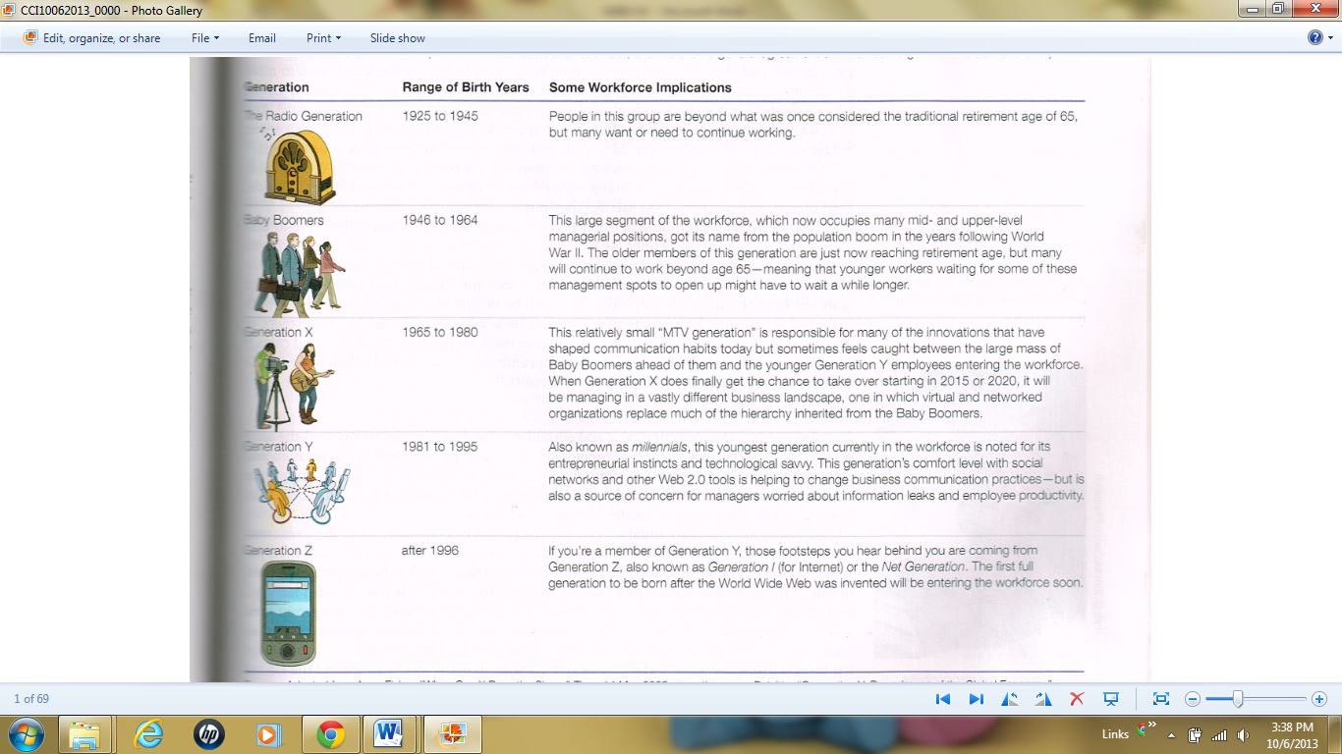
MANAGING THE EMPLOYMENT LIFE CYCLE:
RECRUITING: The process of attracting appropriate applicants for on organisation jobs.
EMPLOYEE RECRUITMENT PROCESS
TERMINATION: The process of getting rid of an employee through layoff or firing
LAYOFFS: Termination of employees for economic or business reasons.
WORKER BUYOUTS: Distributions of financial incentives to employees who voluntarily depart; usually undertaken in order to reduce the payroll.
MANDATORY RETIREMENT: Required dismissal of an employee who reaches a certain age.
The three phases of managing the employment life cycle are hiring, termination and retirement. The hiring phase typically involves six steps; selecting a small number of qualified candidates to identify the most attractive prospects, interviewing these prospects in depth to learn more about them and their potential to contribute to the company, evaluating and comparing interview results, conducting background checks and pre-employing tests, and then selecting the best candidate for each person and making job offers. Termination can involve firing employees for poor performance or other reasons or laying off employees for financial reasons. Retirement offers a variety of companies challenges depending on the industry and the company’s situation; overstaffed companies may include some employees to retire early through buyouts, whereas others that face talent shortages may try to induce retirement-age employees to delay retirement.

PERFORMANCE APPRAISALS: Periodic evaluations of employee’s work according to specific criteria.
360⁰-DEGREE REVIEW: A multidimensional review in which a person is given feedback from subordinates, peers, superiors, and possibly outside stakeholders such as customers and business partners.
ELECTRONIC PERFORMANCE MORNING (EPM): real-time computer-based evaluation of employee performance.
ORIENTATION PROGRAMS: Sessions or procedures for acclimating new employees to the organisation.
SKILLS INVENTORY: a list of the skills a company needs from its workforce, along with the specific skills that individual employees currently possess.
The effort to develop and evaluate employees includes providing performance appraisals, managing training and development programs, and promoting and reassigning employees. Managers use performance appraisals to give employees feedback and develop plans to improve performance shortcomings. In a 360 degree review, an employee is evaluated by subordinates (if applicable), peers and superiors. Training and development efforts begin with orientation for new hires and continue throughout a person’s career in many cases. When employees have reached sufficient skill levels to take on new challenges, they may be considered for promotion into positions or more responsibility.
COMPENSATION: Money, benefits, and services paid to employees for their work.
SALARY: Fixed cash compensation for work, usually by an annual amount; independent of the number of hours worked.
WAGES: Cash payment based on the number of hour an employee has worked or the number of units an employee has produced.
BONUS: A cash payment, in addition to regular wage or salary, that serves as a reward for achievement.
COMMISSIONS: employee compensations based on a percentage of sales made.
PROFIT SHARING: the distribution of a portion of the company’s profits to employees.
GAIN SHARING: tying rewards to profits or cost savings achieved by meeting specific goals.
PAY FOR PERFORMANCE: An incentive program that rewards employees for meeting specific, individual goals.
KNOWLEDGE-BASED PAY: Pay tied to an employee’s acquisition of knowledge or skills; also called competency-based pay or skill-based pay.
For most employees, the bulk of their compensation comes in the form of salary, if they receive a fixed amount per year, or wages, if they are paid by the unit or time or unit of output. In addition to their base salary or wages, some employees are eligible for a variety of incentive programs, including bonuses, commissions; profit sharing, and gain sharing. In some cases, employers offer pay for performance plans that have a lower base salary but allow employees to earn money by hitting specific performance goals. Some companied are also exploring knowledge-based pay, which rewards employees for acquiring information or developing skills related to their jobs.

EMPLOYEE BENEFITS: compensation other than wages, salaries and incentive programs
CAFETERIA PLANS: flexible benefit programs that let employees personalize their benefits packages.
RETIREMENT PLANS: Company-sponsored programs for providing retirees with income. They fall into two groups, define contribution programs, which promise a specific amount per month after retirement, and defined contribution programs, in which the company contributes a certain amount per month or year to an investment account.
PENSION PLANS: generally refers to traditional, defined-benefit retirement plans.
401 (k) PLAN: a defined-contribution retirement plan in which employers often match the amount employers invest.
EMPLOYEE STOCK-OWNERSHIP PLAN (ESOP): A program that enables employees to become partial owners of a company.
STOCK OPTIONS: a contract that allows the holder to purchase or sell a certain number of shares of a particular sock at a given price by a certain date.
Other important benefits are paid vacations and sick leave, family and medical leave, child and elder-care assistance, tuition reimbursements or loans, and employee assistance programs that deal with personal matters such as substance abuse or domestic violence.
EMPLOYEE ASSISTANCE PROGRAMS (EAP): a company-sponsored counseling or referral plan for employees with personal problems.

LABOUR RELATIONS: The relationship between organised labour and management (in its role as the representative of company ownership).
LABOUR UNIONS: organisations that represents employees in negotiations with management.
SENIORITY: the length of time someone has worked for his or her current employer.
WORK RULES: a common element of labour contracts that specifies such things as the tasks certain employees are required to do or are forbidden to do.
LABOUR UNIONS are organisations that seek to protect employee interests by negotiating with employees for better wages and benefits, improved working conditions, and increased job security. The foundation of unionization is strength in numbers, giving workers the opportunity to negotiate on a more equal footing with company management. From an employer’s perspective, unions can present challenges in terms of costs and flexibility, ultimately creating concerns about a firm’s ability to compete against companies with lower costs and greater agility.
NATIONAL LABOUR RELATIONS ACT: legislation passed in 1935 that established labour relations policies and procedures for most sectors of private industry; aka. Wagner act.
LABOUR MANAGEMENT RELATIONS ACT: Legislation passed in 1947 that addressed many concerns raised by business owners and shifted the balance of power again; aka. Taft-Hartley Act.
LABOUR MANAGING REPORTING AND DICLOSURE ACT: Legislation passed in 1959 designed to ensure democratic processes and financial accountability within unions; aka. Landrum Griffith Act.
UNION SECURITY: measures that protect a union’s right to represent workers.
UNION SHOP: A unionized workplace in which employees required to maintain union membership
RICHT-TO-WORK LAWS: State laws that prohibit union and agency shops.
LOCALS: Local unions that represent employees in a specific geographic area or facility
NATIONAL UNION: a nationwide organisation composed of many local unions that represent employees in specific locations.
AUTHORIZATION CARDS: Cards signed by employees to indicate interest in having a union represent them.
CERTIFICTION ELECTION: a secret-ballot election overseen by the NLRB to determine whether a union gains the right to represent a group of employees.
DECERTIFICATION: an employee vote to take away a union’s right to represent them.
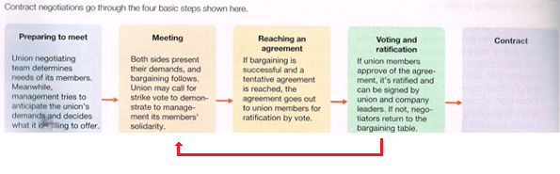
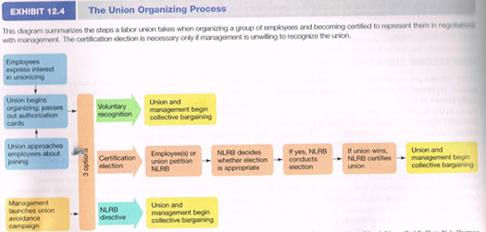
COLLECTIVE BARGAINING: a negotiation between union and management negotiators to forge the human resources policies that will apply to all the employees covered by a contract.
MEDIATION: Use of an impartial third party to help resolve bargaining impasses.
ARBRITRATION: a decision process in which an impartial referee listens to both sides and then makes a judgment by accepting one side’s view.

