WEEK 9-EMPLOYEE MOTIVATION:
Nothing happens in our world without motivation.
MOTIVATION: Motivation is not about whether you can do something but about whether you want to do something (are you keen to do it? Do you have a desire/interest in doing it?). All human performance inside and outside the workplace depends on both ability (‘can do’) and motivation (‘will do’).

Content theories on motivation: the role of human needs and how we are more motivated to our needs
Process theories of motivation: the way we go about a particular task deciding whether or not to approach it and feel about the things we do: expectancy and equity.
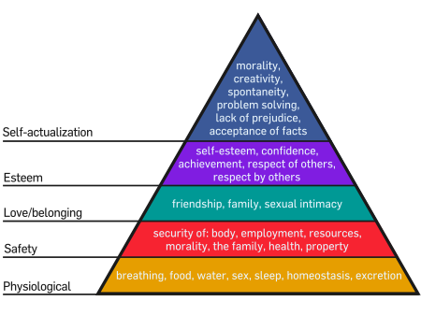
-Human beings are motivated to satisfy their needs, as visualized in Abraham Maslow’s “hierarchy
of needs” and his fundamental principle was that humans are motivated toward their unfulfilled
needs. In other words we have certain needs and we seek to meet or to satisfy these needs.
The most fundamental of needs are at the bottom of the pyramid and these
are our basic physiological needs, they are obviously needs to breathe air, have clean water, to have food, shelter, to have good sleep, that include the sex drive, (needs we are motivated to meet).
-Secondly, we are motivated to ensure we have personal safety and security. We like to be in environments where we don’t feel threatened, where we are aware about our daily business in a secure manner.
-The next level is about a sense of love and relationships, about feeling that you belong in the human community, about forming human bonds with human beings in close valuable ways.
-The next level is about your personal self-esteem, do you feel good about yourself? Do you see yourself as a person of worth, do you value yourself as a person, (a higher level of need).
-The final need is what Maslow called SELF-ACTUALISATION/self-fulfillment, in other words there is something about you as a unique human being, which is about your total potential and is about all the things that you are capable of doing/becoming. In other words, we strive alternatively to reach our potential, to grow as a human being who has talents and creativity and we seek to reach and explore all of our potential that is within each one of us.

LOTS OF MOTIVATIONAL THEORIES HAVE BUILT ON THIS FUNDAMENTAL PRINCIPLE- that human beings strive to meet their needs.
FOR EXAMPLE: Nitin et al’s four drives (to acquire resources, to defend, to bond and relate to other human beings {we are social human beings and we need to have some level of socialization}, to comprehend {to learn, to grow and to meet our individual potential}). There are lots of variations on the list Maslow came up with. (there are different advantages and disadvantages to each approach) Human beings have needs and we act to satisfy our unfulfilled needs
IN SUMMARY human needs are grouped into two broad categories:
SURVIVAL NEEDS: People are motivated to seek money through being an employee, starting their own business, joining the workforce etc…(which enables survival and meet our basic needs for food, security, shelter etc…) Thus money is always a fundamental human motivation. People come to work because in work an employer promises a certain amount of money in exchange for a service that the employer provides.
GROWTH NEEDS: But people also seek to apply skills as time goes by and we gain commitments in life, we wish to find meaning in work, to reach their potential, to make bonds with others, travel as time goes by. However these require high amounts of money, people often revise upwards their needs for survival when they seek more money.
However money is not the only motivator-IMPLICATION: if managers want to motivate people over the long-term, they must enable them to grow (we have needs for personal growth, we as human beings are seeking to apply the skills that you acquire through life, work experience etc… We seek to find meaning in what we do so we are attracted to some organisations more than others, because the work offered is more fulfilling and meet our potential and have meaning in our lives to grow as human beings). Being bored is one of the most important reasons as to why people leave their jobs. Money is only a short-term motivator, in the long term to get the most out of people their higher order needs must be catered too (needs to grow and a sense of development).
PROCESS THEORIES OF MOTIVATION: EXPECTANCY THEORY
-VALANCE/VALUE: is the idea that there are certain rewards that appeal to you, there are certain rewards in an organisation that you are attracted to (money/status/promotionusing more of your potential)
We are REWARD-SEEKERS as human beings and we are attracted to particular types of rewards depending on your personal needs (personal goals, values and preferences) Rewards are needed to motivate people.
-INSTRUMENTALITY: Personal perception of whether or not you have confidence that in this workplace if you do the right thing your performance will lead to a desired reward belief that management can be trusted and you will be rewarded because you have confidence your organisation is fair.
-EXPECTANCY: You must believe in yourself to a certain extent, believe that if you make the effort in the organisation your efforts will lead to a good performance, you are capable of doing the job.

The LEVEL OF MOTIVATIONAL FORCE within you depends on whether you believe you can do the job, the reward system is going to notice you and finally the reward is something you truly value. =POWER OF MOTIVATION.

PROCESS THEORIS OF MOTIVATION: EQUITY THEORY: (are rewards fair inside the organisation executive pay)
Are executives or large companies being overpaid for the work that they do, and do they get the correct rewards for what they do. e.g. In USA Wall Street crash, Bank CEO’s still received high amounts of wages when the average tax payer and employees suffered. EXECUTIVES ALWAYS COME OUT AS WINNERS.
-Public concern about level of executive pay, should executives be paid such high amounts in crisis situations (>400x the average bank employee), therefore the average worker is undervalued and overvalued the value of the bank executives.
-Reward systems should reward not only the right people BUT the right kind of BEHAVIOUR. {Perversity or perverse outcomes}, in other words, if we reward people with money for reaching goals in the short-run, people will perform, but in the long run there will be a reverse impact on the business, shareholders will be undermined.
MANAGERS NEED TO BE AWARE OF THE IMPORTANCE OF EQUITY IN PAY SYSTEMS AND SHOULD AIM TO MINIMISE PERVERSE INCENTIVES.

BEING A MANAGER:
Emphasising the difficulty of managing people: The hardest part of being a manager is being good at motivating other people, LEADING and helping other people to perform at their best, because people are different, and hence there are challenges in leading a team.
PROMOTION TO MANAGEMENT: Graduates are hired initially for specialist or technical roles based on their studies (entry level positions): subsequently some are promoted to management roles if they are good enough to lead others toward Organisational goals. A shift from a technical to leadership roles to work towards common goals.
-This involves a shift in responsibilities, which suits some people’s interest and abilities, and not others.
EDGAR SCHEIN’S ‘CAREER ANCHORS’: Managers lead others to get results and meeting business goals in important in management accountabilities which is a level of accountability for their actions.

Managers are people who lead others to get results for the organisation. Management know-how builds through experience on the job and through management development processes, e.g. management ‘cadetships’; cross-functional teamwork; mentoring programmes; acting leadership and project leadership roles; international secondments; short courses; postgraduate management degrees receiving on the job experience and learning from outside your comfort zone. PAYING ATTENTION TO WHAT STYLES WORK with different employees

Therefore, managers need certain types of skills:
-TECHNICAL SKILLS: Managers are promoted up from technical roles, and when they are at a position of significant importance they still need technical skills to understand what is takes to manage,
-CONCEPTUAL SKILLS: need to be able to think issues through, to intellectualise complex issues BUT manage the people who need to be intellectually skillful and listen to/understand other people’s points of view.
-INTERPERSONAL SKILLS: Lead people in a team and give attention to certain employees to understand their needs and bring out the best in them.
-DECISION MAKING SKILLS: Need to be people, who are not frightened of decision making, are able to make and be accountable for their decisions.

MANAGERIAL ROLES: Behavioural patterns and activities involved in carrying out the functions of management; includes intrapersonal, informational and decisional roles.
-INTERPERSONAL: Getting worked accomplished through the efforts of other people. Managers must provide leadership to employees, help building relationships, and acting as a liaison between groups and individuals both inside and outside the company. In fact, the number of connections a person has become an increasingly important asset the higher he or she raises in an organisation.
-INFORMATIONAL: The higher up a manager is in a company, the more they rely on subordinates to collect, analyse, and summarize information for managers. Today’s companies have devised powerful and clever ways to collect and process information for managers. A good example= EXECUTIVE DASHBOARD, which provides quick-read summaries of vital performance variables. Latest generation technology (software) makes it easy to customise screens to show each manager their specific summaries.
-DECISIONAL: Managers must have very strong long-term and short term decision making skills. One of the most significant changes occurring in business management in recent years is the effort to push decision making as far down the organisational pyramid is possible, giving whichever employees face a particular situation the authority to make decisions about it. This approach accelerates and improves work flow and customer service as well as freeing up higher level managers to work on more strategic matters.

MANAGEMENT ROLES, FUNCTIONS, AND SKILLS:
MANAGEMENT: The process of planning, controlling, organizing, leading and controlling to meet organizational goals.
PLANNING: Establishing objectives and goals for an organisation determining the best ways to accomplish them.
STRATEGIC PLANS: Plans that establish the actions and resource allocation required accomplishing strategic goals, they’re usually defined for periods of 2-5 years and developed by top managers.
MISSION STATEMENT: A brief statement of why an organisation exists; in other word, what the organization aims to accomplish for its customers,… and other stakeholders.
VISION STATEMENT: A brief and inspirational expression of what a company aspires to be
VALUES STATEMENT: A brief articulation of the principles that guide a company’s decisions and behaviours.

WHILE PLANNING, the managers must:
-Form a SWOT analysis, develop forecasts (both qualitative and quantitative in nature), Analyse competition, establish goals and objectives, develop action plans

ORGANISING: The process of arranging resources to carry out the organisation’s plans.
MANAGEMENT PYRAMID:
-TOP MANAGERS: Those at the highest level of the organisations management hierarchy; they are responsible for setting strategic goals, and they have the most power and responsibility in the organisation.
-MIDDLE MANAGERS: Develop plans to implement the goals of top managers and coordinate the work of first-line managers.
-FIRST-LINE MANAGERS: At the lowest level of the managerial hierarchy, they supervise the operating employees and implement the plans set at the higher management levels.

LEADERSHIP:-MANAGER TYPES:
-AUTOCRATIC: Manager makes the decisions without consulting others.
-DEMOCRATIC: Managers share decision making authority, seeking input and inviting subordinates to participate in the planning process.
-LAISSEZ-FAIRE: Manage acts as advisor and supporter, offering input when asked but generally letting subordinates chart and adjust their own course toward meeting agreed-upon goals and objectives.
-PARTICIPATIVE MANGERS: A philosophy of allowing employees to take part in planning and decision making.
-EMPLOYEE EMPOWERMENT: Granting decision making and problem solving authorities to employees so they can act without getting approval from management.
-COACHING: Helping employees reach their highest potential by meeting with them, discussing problems that hinder their ability to work effectively, and offering suggestions and encouragement to overcome these problems.
-MENTORING: A process in which experienced manager’s guide less experienced colleagues in nuances of office politics, serving as a role model for appropriate business behaviour, and helping to negotiate the corporate structures.

ORGANISATIONAL CULTURE: A set of shared values and norms that support the management system and that guide management and employee behaviour.
SCIENTIFIC MANAGEMENT: thoroughly studying and testing different work methods to identify the best, most efficient way to complete a job.
SOLDIERING: when workers deliberately slow their pace or restrict their work outputs.
RATE BUSTER: a group member whose work pace is significantly faster than the normal pace in his or her group.

THEORY OF FREDERICK W. TAYLOR: StudyAnalyse Determine the “one best way” to do a job. Then train, teach and develop workers to reach their full potential. So that what is good for workers is ALSO good for managers.

FRANK AND LILIAN GILBERTH:
TIME STUDY: timing how long it takes good workers to complete each part of their jobs and paying likewise.
MOTION STUDY: breaking each task or job into its separate motions and then eliminating those that are unnecessary or repetitive

HENRY GANTT:
Gantt chart: a graphical chart that shows which tasks must be completed at which times in order to complete project or task.
Workers achieve their best performance levels when trained first.

WEBER:
BUREAUCRACY: the exercise of control on the basis of knowledge, expertise or experience.

ORGANISATION: a system of consciously coordinated activities or forces created by two or more peoples.
JOB CHARACTERISITICS MODEL: A model s
JOB ENRICHMENT: Making jobs more challenging and interesting by expanding the range of skills required.
CROSS TRAINING: Training workers to perform multiple jobs and rotating them through these various jobs to combat boredom or burnout.
REINFORCEMENT THEORY: A motivational approach based on the idea that managers can motivate employees by influencing their behaviours with positive and negative reinforcement.
POSITIVE REINFORCEMENT: Encouraging desired behaviours by offering pleasant consequences for completing or repeating those behaviours.
NEGATIVE REINFORCEMENT: Encouraging the repetition of a particular behavior (desirable or not) by removing unpleasant consequences for the behavior.
INCENTIVES: Monetary payments and other rewards of value used for positive reinforcement.
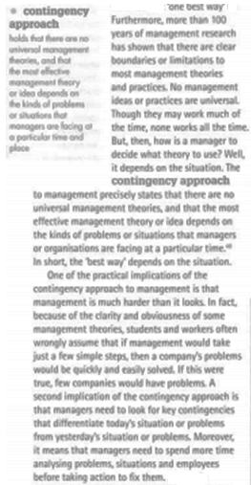
MARY PARKER FOLLETT:
INTEGRATIVE CONFLICT RESOLUTION: an approach to dealing with conflict in which both parties deal with the conflict by indicating their preferences and then working together to find an alternative that meets the needs of both.
THREE-NEEDS THEORY: David McClelland’s model of motivation that highlights the needs for power, affiliation and achievement.
MOTIVATION: The combination of forces that move individuals to take certain actions and avoid other actions.

ENGAGEMENT: An employee’s rational and emotional commitment to his or her work.
Employees are fully motivated when they are engaged, satisfied, committed and rooted.
THE HAWTHORNE EFFECT A supposed effect of organisational research in which employees change their behavior because they are being studies and given special treatment; the validity of the effect is uncertain, and the Hawthorne studies were richer and more influential than this simple outcome would suggest.
- (commonly referred to as the observer effect) is a form of reactivity whereby subjects improve or modify an aspect of their behavior, which is being experimentally measured, in response to the fact that they know that they are being studied, not in response to any particular experimental manipulation.

THEORIES:
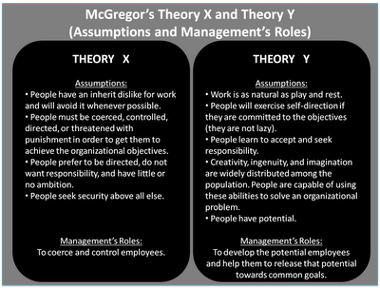
MASLOW’S HIERARCHY: A model in which human needs are arranged in a hierarchy, with the most basic needs at the bottom and the more advanced needs at the top.
THEORY X: A managerial assumption that employees are irresponsible, are unambitious, and dislike work and that managers must use force, control, or threats to motivate them.
THEORY Y: A managerial assumption that employees enjoy meaningful work, are naturally committed to certain goals, are capable of creativity, and seek out responsibility under the right conditions.
HERZBERG’S TWO FACTOR THEORY: A model that divides motivational forces into satisfiers and dissatisfiers.

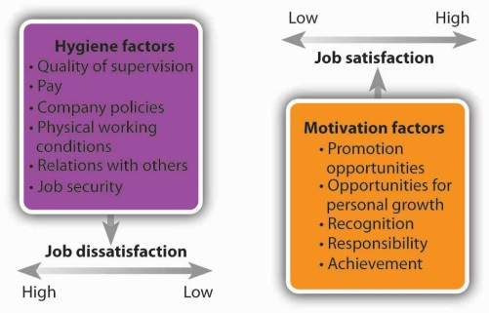

EXPECTANCY THEORY: The idea that the effort employees put into their work depends on expectations about their own ability to perform, expectations about likely rewards and the attractiveness of those rewards. The quality of the effort put forth depends on: individual effort, individual performance,
organisational rewards and individual goals.
EQUITY THEORY: The idea that employees base their level of satisfaction on the ratio of their inputs to the job and the outputs or rewards they receive from it.
GOAL SETTING THEORY: A theory suggesting that setting goals can be an effective way to motivate employees. Goals must be SMART.
MANAGEMENT BY OBJECTIVES (MBO): A motivational approach in which managers and employees work together to structure personal goals and objectives for every individual, department, and project to mesh with the organisation’s goal. Setting goals (top, middle and lower managers work with each other to do so)Planning actionImplementing plansReviewing performance (circular motion)
DISADVANTAGES OF GOAL SETTING: Overly narrow goals, overly challenging goals, too much emphasis of short term goals and less on long term goals, unintentional performance limitations, missed learning opportunities, unhealthy internal competition, and decreased intrinsic motivation.
JOB CHARACTERISTIC MODEL: A model that five core job dimensions influence three critical psychological states that determine motivation, performance, and other outcomes. Skill variety, task identity, task significance, autonomy and feedback.
-Experienced meaningfulness of the workexperienced responsibility of resultsknowledge of actual results

PERSONALISING MOTIVATION: Establish systems and policies that are fair and automaticBe as flexible while still being fairGet to know employees as individuals.
MICROMANAGING: Overseeing every small detail of employee’s work and refusing to give freedom or autonomy.
Managers can motivate employees more effectively by (1) providing timely and frequent feedback, (2) personalizing motivational efforts as much as much as possible while still being fair to all employees, (3) adapting motivational tactics to circumstances and special needs, (4) addressing workplace negativity before it has a chance to destroy morale, and (5) being inspirational leaders.

