Business102 Notes - Webcasts

Week 1 – Understanding the business context (the external business environment)

3 levels of the environment
- Internal – within the company
- Micro-environment – shareholders/stakeholders, customers
- Macro-environment – PESTE / Porters
  - PESTE (for an individual business and/or industry) = Political, Economic, Social/Socio-cultural, Technological, (Environmental)
  - Porter’s Five Forces (industry only) = Buyer power, supplier power, threat of new entrants, threat of substitutes, rivalry amongst competitors

Week 2 – Innovation and entrepreneurship

Definitions
- Innovation: The conversion of existing knowledge and ideas into new or improved products, processes or services which may be used for commercial purpose of the public good
- Entrepreneurship: The process of creating or seizing an opportunity and pursuing it to create value, regardless of current available resources
- Creative destruction: Replacing a current existing product with a new and improved product, thus destroying the existing product and industry.
  - Typewriters “creatively destroyed” by the personal computer/laptop industry
- Radical change: A complete redesign of a product
  - Telegram landline phone mobile phone
- Incremental change: A small improvement of a product
  - iPhone 4 iPhone 4S iPhone 5

“Toolbox” of innovation
- Turning ideas into opportunities requires:
  - The ability to spot an opportunity
    - Ideas don’t shout, they whisper
  - A business plan and business model
  - Personal networks – arranging contacts with other individuals and businesses
  - Investing money / raising capital

Week 4 – Business Models

What is a business?
- An organisation engaged in the trade of goods or services to customers
- Being busy doing commercially viable and profitable work

Capturing and creating value
- Creating value: A firm’s ability to create value for the customer - customer benefits from the product we are selling
- Capturing value: A firm’s ability to capture value from the customer – generally in the form of money, establishing long-term relationships, or gathering feedback
- Balancing is the key to long-term success

Business models and BM canvas
- Maps out how the firm captures and creates value

Key partners | Key activities | Value propositions |  | Customer relationships | Customer segments
 | Key resources |  |  | Channels
Cost structure |  |  | Revenue streams

- Firms compete through different business models

Why are business models important?
- Product innovation is not enough
- Business model innovation is required to create and capture value
- The internet challenges all existing business models due to changing communications

Week 4 – Sustainability

Sustainable development
- Sustainable development is that which meets current needs without compromising the ability of future generations to meet their own needs.

Four key principles
- Reduce dependence upon fossil fuels
- Reduce dependence upon synthetic chemicals and unnatural substances
- Reduce encroachment upon nature
- Meet human needs fairly and efficiently

Balance of three elements
- Environmental (not damaging the planet)
- Economic (must remain profitable)
- Social (meeting standard of living, community…)
  - Leads to triple bottom line reporting

Consequences of non-sustainability
- Damage to the planet
- Consumption of non-renewable resources
- Damage to reputation

Sustainability as an opportunity
- Viewing compliance as opportunity
- Making value chains sustainable
- Designing sustainable products and services
- Developing new business models

- Sustainability increases customer loyalty

Week 5 – Marketing and understanding consumers

Two markets
- Consumer market – businesses selling to individuals and families
- Business/organisational market – businesses selling to other businesses

Consumer market
- Often features impulse buying
- Often brands are more important than price
- Generally only buyer and seller – no third parties

Motivation and involvement
- Motivation determines our behaviour
- Involvement is a particular aspect of motivation which marketers are interested in

- Involvement is low when a consumer has no interest in purchasing the product (often the case in day-to-day shopping e.g. groceries)
- Involvement is high when a consumer is interested in purchasing a product

Consumer process decision
- Low involvement
  - Need recognition (that we need some)
  - Purchase
  - Post-purchase evaluation (doesn’t often happen)
- High involvement
  - Need recognition
  - Information search
  - Evaluation of alternatives
  - Purchase
  - Post-purchase evaluation (more often than low-involvement)

Business market
- Driven more by economics than emotion
- Formal buying process – less impulse buying
- Needs of majority are important, rather than the individual
- A number of people involved in purchase decision
- Established relationships

Targeting the consumer

Problems
- Consumers may have ‘problems’
- They may not always be aware of these problems
- Marketers develop programmes and introduce product that solve these problems

Investigating problems
- Quantitative – Surveys and experiments
- Qualitative – Interview, focus groups, understand emotion (increases involvement)
  - Involve conversations with consumers (one on one)

Marketing strategies
- Marketers are in the business of satisfying customer needs and wants – but what if…
- I need it but I don’t want it, or
- I want it but I don’t need it

- Rational (concrete) – needs and wants are based on logical thinking
- Emotional – needs and wants are based on feelings – impulse buying occurs here
- The job of a marketer is to persuade customers that their product will solve consumer problems!

4 eras of marketing

Production
- Pre 1920’s
- A good product will sell itself
- Product orientated focus
- However, product is not a guarantee of success unless consumers want it

Sales
- 1920’s to 1950’s
- Focused on advertising goods to consumers
- Sales orientation

Marketing
- 1950’s to 1990’s
- Focus becoming more about meeting consumer needs
- Consumer orientation
- Buyer’s market
  - More sellers than buyers
  - Higher buyer power
  - Thus firms need to attract buyers

Relationship
- 1990’s onwards
- Focus becomes on retaining customers for a lifetime
- Consumer relation orientation

Week 6 - Strategic marketing – segmentation, targeting and positioning

Four key steps to develop marketing strategies
- Segmentation: Marketers cannot expect to satisfy everyone’s wants and needs with one product, so we need to determine our target market that we can serve best with our existing products or ones we can create.
- Competitive differentiation: We try to do something different to the existing solutions on the market, but this difference needs to be something important to consumers.
- Positioning: Need to make customers aware of us so we are ‘positioned’ on the customer’s mind.
- Design the marketing mix: Next week.

Segmentation
- We segment the market members into groups with similar characteristics and needs
- We do not segment products!

Methods
- Demographics (age, gender, income etc)
- Psychographics (lifestyle, interest, attitudes, values) - Anchor Milk example
- Geographics (where people live) – cities, regions, countries, continents

Differentiation
- Can we find differences that are important to our customers that will set us apart?
- Low cost
- Differentiation – depends on the product or service
  - Lighter
  - Faster
  - Easier to use
  - Better service
  - Lasts longer
  - Healthier
  - More options
  - Is it difficult to copy or beat?

Positioning
- Telling why it’s better
- Getting onto the customer’s shopping list
- Having consistent brand communication
- Creating the desired brand perception
- Re-positioning: Creating a new impression of our business, or re-enforcing our point of difference

Week 7 – The Marketing Mix (4 P’s) – Product, Price, Place

Product
- Good or service is not just the ‘thing’
- Companies create value by developing a comprehensive market offering
- The offering is a mix of attributes about the product which provide benefits to target customers

- Starts with a core benefit (basic major function – iPod = music player)
- Add more benefits – actual product (brand, features, design, quality, packaging)
- Additional benefits – augmented product (accessories, warranty, service after sale, upgrades)

- Some products are complex – have more than one core benefit – depends on consumer needs
- Good = tangible; service = intangible – however, most products lie in the middle

Place
- Also called channel of distribution
- Where products and services are sold
- Can be physical (shop) or online (TradeMe)

Price
- What we end up paying
- Price is important – income pays for expenses
- Promotions may include price drops to attract initial interest
- Value is what you get for what you pay
- For example, an expensive product lasts longer, cheaper product more prone to breakage

Week 7 – The Marketing Mix (4 P’s) - Promotion

Aspects of marketing / customer communications
Many aspects including:

- Public Relations
- Advertising
- Packaging
- Sales Promotion
- Telemarketing
- Point of Sale
- Brand values
- Signage
- Uniforms
- Direct mail
- Personal selling
- Internet
- Social media
- Image and positioning

Integrated market communication
- Co-ordinating all aspects in a consistent manner
- Integrating them with the other marketing activities
- A team effort, not just individual ideas
- Greater synergy = greater effectiveness

Integrated customer communication
- As above, but including:
  - Word of mouth
  - Product
  - Price
  - Place (location of store)
  - People
  - Physical place (store layout)
  - Process

Say-do triangle
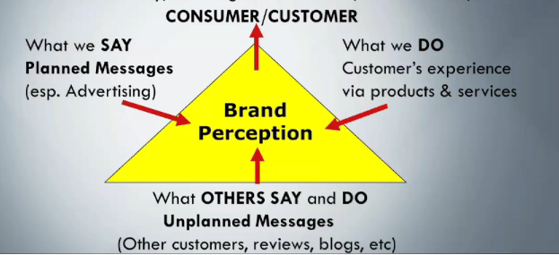

Changing customer communications paradigm
- Communication used to be purely one way – company to customer (planned messages)
- Now it is many ways – company to customer, customer to company, customer to customer
  - Many more unplanned messages
  - “A brand is no longer what we tell the consumer it is. It’s what consumers tell each other it is” – Scott Cook.

Changing media
- Mass media (one-to-many)
- Segmented media (one-to-few)
- Personal media (one-to-one)
- Social media (many-to-many)

Week 8 – Co-creation of value

What is co-creation?
- Roles of customers are changing, as they wish to become more involved in the development and creation of value
- Thus, businesses work alongside customers to create value based upon their needs
- For example, taking customer’s ideas and wants and developing them into to satisfactory products
  - World of Warcraft – players suggest game updates
  - Threadless – online shirt company where users design and vote on T-shirts

Week 8 – Customer Lifetime Value

What is customer lifetime value?
- The value of all the cash flows created by the relationship with the customer
- Emphasis on long-term relationships
- A firm’s value is improved by increasing value of the customer relationships
- Focus on retaining existing customers over acquiring new ones

3 aspects & how to improve
- Time - The length of the relationship with the customer
  - Deliver value to the customer
  - Good customer service
  - Personalised services
  - Loyalty programmes / Fly Buys
- Frequency - Number of times during a period that a customer purchases from a firm
  - Extra purchase – buy one get one free, loyalty cards
- Share of wallet - The proportion of the customer’s spending that goes to the firm
  - Bundling – combos, upselling, cross-selling

Week 9 – Being a manager

What is management?
- Managers lead others to get results
- Work with people to ensure business goals are met
- The most difficult aspect is managing people as they have different needs

Promotion to management
- Graduates hired for specialist or technical roles, tested out, and may then be promoted to management
- Shift of responsibilities from simple technical expertise to managing people

Management know-how
- Different to technical competence
- Requires experience to develop
  - Work experience on the job
  - Manager development processes
  - Insight to the business’s work style
  - Cross-functional teamwork (working in other departments)
  - Postgraduate management degrees (MBA)
  - Mentoring programmes

Needed skills
- Technical skills
- Conceptual skills
- Interpersonal skills
- Decision-making skills

Week 9 – Motivation and motivational theories

What is motivation?
- The want to do something
- People have survival needs and growth needs

Motivation theories

Maslow’s pyramid (hierarchy of needs)
- Physiological (food, water, air, shelter, sleep, sex)
- Safety and security
- Love and belongingness
- Self-esteem
- Self-actualisation (meeting maximum potential)

More under readings

Week 10 – Workforce management

Changing workforce
- The aging workforce
- Growing workforce diversity
- Changes in national balances / international division of labour
- Growing connectedness through technology
- The uneven spread of work – overworked workers (stress and health)
- Declining unionism

What is workforce management?
- The goal is to attract and retain the people the business needs, motivating and developing them in a way that generates the required performance at a cost the business can afford

Employment cycle
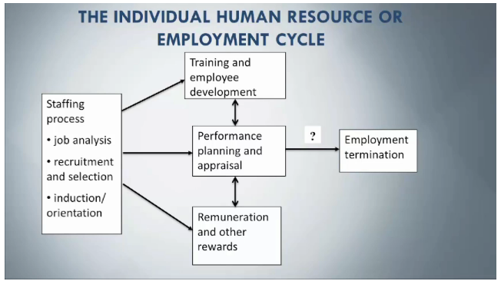

Week 11 – Operations and supply chain management

What is operations management?
- The monitoring of transformation of inputs (raw materials, labour, capital, information) into outputs (goods and services), and feedback.
- Two types of processes – manufacturing and services

Operation topics
- Operations strategy – capacity of outputs, facilities for production, process technology, workforce management, sourcing (outsourcing, make vs. buy), quality of outputs
- Forecasting – future sales
- Capacity management
- Process design – volume requirements, level of customisations
- Process improvement – less waste, increased speed or quality, lower costs
- Product design and quality – customer preferences and needs
- Performance measurement
- Inventory and resource planning

Supply chain management
- Supply chains bring products to customers and consist of all the interactions between suppliers of raw materials and customers.
- SCM ensures alignment of strategy and operations with suppliers and customers through communication and information flows (INFOSYS110 anyone?)
- No organisation operates independently

- Example: Raw materials, integrator/producer, wholesaler, broker, retailer, consumer
- Demand flows left, product flows right, information flows both ways
- More often networks than linear models

What is operations success?
- Ensuring a good fit between operational strategy and the business vision
- Ensuring that operations are well aligned with other business functions (marketing, accounting, sales etc.)
- Operations matching customer expectations
- Managing trade-offs and tensions that arise when pursuing goals

Extra readings notes :’(

Week 1

The global marketplace
- Business environments – Economic, Market, Legal and Regulatory, Social, Technological
- Nations trade for various reasons: Relative strengths and availability of resources, new markets for increased revenues, expanding customers etc.
- Free trade/fair trade/ government interventions in trade
- There are cultural and legal difference around the world which need to be worked with

Week 2

Drucker’s sources of innovation
- Internal to a market or industry – unexpected occurrences, incongruities (between needs and existing solutions), process needs (to make processes better), industry and market changes
- External – demographic changes, changes in perception (rise in health awareness), new knowledge

Principles of innovation
- Search for new opportunities
- “Go out [to people] and look, ask and listen”.
- Simple and focused; don’t try to revolutionise the industry; be specific

Entrepreneurship
- Not a personality trait
- Not starting up a small business
- Not copying existing businesses
- Searching for change
- Creating new markets and finding new customers

Week 4

Business models
- Customer segments = target market (mass, niche, segmented etc.)
- Value proposition = the bundle of products and services that create value
- Channels = how we communicate and deliver our value proposition to customers
- Customer relationships = I customers.
- Revenue streams = how we get money
- Key resources = assets needed to make the business run (includes people)
- Key activities = the important things we do
- Key partnerships = network of suppliers and partners, how do we work with competitors
- Cost structure = expenses

Other reading (can’t think of a good heading)
- This diagram can’t spell business, but is otherwise important
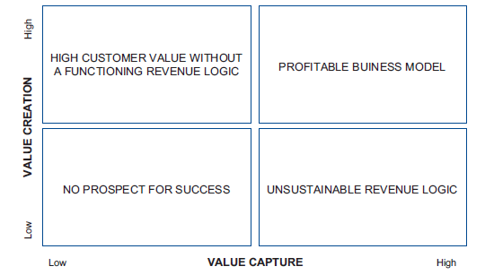

Sustainability
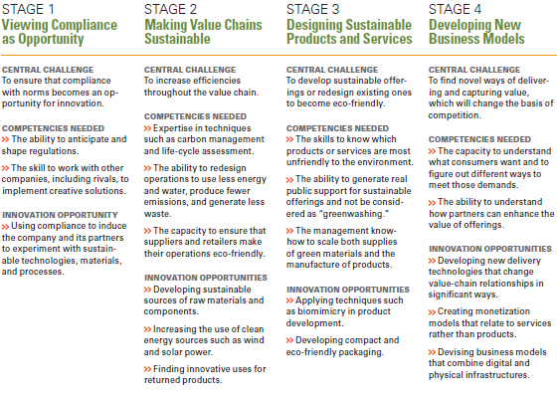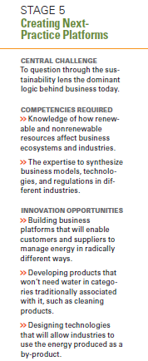

- Sustainability requires a future view, not just looking at the present
- Ensure that learning precedes investments – understand what you are doing
- Stay focused on your goals, even if changing tactics
- Build collaborative capacity – work together
- Use a global presence to experiment – work in different markets to see what works where

Week 5

The art and science of marketing
- Marketing is the process by which companies create value and build customer relationships in order to capture value.
- 4 utilities of a product to deliver value – form utility (a physical product), time utility (saving time), place utility (convenient locations), possession utility (owning something – may not be physical)

- Trends
  - Customer wants to be more involved
  - Data-driven decisions (market research)
  - Concerns for ethics and etiquette

Marketing myopia
- What business are you really in?
- Don’t be too specific (myopia = short-sighted)
- Being too specific means you will be less likely to adapt to changes

Week 6

The Art and Science of Marketing
- Strategic marketing planning
  - Examine the current market situation (past performance, competition, SWOT and external environment)
  - Assess market opportunities and set marketing objectives
  - Develop a marketing strategy
    - Market penetration (existing products, existing markets)
    - Product development (new products, existing markets)
    - Market development (existing products, new markets)
    - Diversification (new products, new markets)

Week 7 (so many readings…)

Smart watches

Types of products
- Convenience products (everyday goods, not much effort put into purchase)
- Shopping products (less common, but still needed, some effort put into purchase)
- Specialty products (sought after particularly)
- Unsought products (things that customers don’t want to think about)

Product development and lifecycle
- Idea generation
- Idea screening
- Business analysis
- Prototype development
- Test marketing
- Commercialisation
- Introduction
- Growth
- Maturity
- Decline

Brands
- Brand = a combination of name, term, sign, slogan, design to identify a product/firm
- Brand equity = value of the brand
- Brand loyalty = the degree to which customers continue to purchase a specific brand
- Brand names = the part of a brand which can be expressed in letters or numbers
- Brand mark = the part which cannot be expressed verbally
- Logo = a small graphic representing a brand

Distribution
I can’t be bothered.

Customer communication
- Needs to be effective and compelling
- Have clear goals
- Be cost-effective
- Don’t break the law

Advertising
- Can use logic, emotion, humour, celebrities, music, sex, scarcity (limited edition)
- Indirect - Found in television, radio, newspaper, product placement etc.
- Direct – Mail/e-mails/phone calls to customers, search engine marketing

Other general stuff
- Promotions – deals to attract interest
- Social media is important
- Public relations is also important

Week 8

Co-creation reading
- Customers have more options but seem less satisfied
- Customers want to be more involved in the production process
- Shifting from a product/firm-centric view to personalised customer experiences
- Market is becoming a forum for conversation between firms and customers

- Traditional view of marketing – market is a place for value exchange and extraction
- Now become a place of interaction and value creation

- Co-creation is about joint creation of value by the company and the consumer
- Allowing the customer to create their experience
- Joint problem definition and solving

- Building blocks: DART
  - Dialogue (communication)
  - Access (how much access does the customer have to our data?)
  - Risk-benefit analysis / risk-reduction
  - Transparency (how honest are we?)

Week 9

Classic motivation theories
- McGregor’s Theory X and Y
  - X assumes employees need to be motivated by others and need extrinsic rewards
  - Y assumes employees are self-motivated by intrinsic rewards
- Herzberg’s Two Factors
  - Hygiene factors (dissatisfying experiences, mostly extrinsic)
  - Motivators (satisfying experiences, more intrinsic)
- McClelland’s Three Needs
  - Power, affiliation (acceptance) and achievement

Contemporary motivation theories
- Expectancy theory
  - The idea that the effort employees put in depends on how they feel about their ability to perform, expectations of rewards and their attractiveness related to personal goals
- Equity theory
  - The idea that employees base their satisfaction on the ratio of their inputs to the job and the outputs they will receive
  - In an purely equitable situation, all employee ratios will be the same (but this never happens)

Other motivation techniques
- Goal setting and objectives
  - Encouraging employees to meet goals within a certain time period
  - Can be risky – goals are too easy/difficult, time issues, missed learning opportunities, internal competition, decreased intrinsic motivation
- Reinforcement
  - Positive reinforcement – rewarding a desirable behaviour
  - Incentives – monetary payments and other valuable rewards
  - Negative reinforcement – removing a consequence of bad behaviour
  - Punishment
- Job enrichment
  - Expanding job description so employees earn new skills
- Job rotation
  - Give employees chances in a new role
- Managerial strategies
  - Providing employees with feedback
  - Being personal
  - Changing to meet specific needs
  - Addressing workplace negativity
  - Being inspirational leaders
    - Walking the walk
- Micromanaging
  - Generally a bad idea – keeping an eye on employees 24/7 to make them work

Job characteristics model
- Job dimensions: Skill variety, task identity (what role am I in this task), task significance (on peoples’ lives), autonomy, feedback
- Critical psychological states: Experienced meaningfulness of work, experienced responsibility for results, knowledge of actual results
- Personal and work outcomes: Higher motivation, improved performance, greater job satisfaction, lower absenteeism and turnover

History of management
- Scientific management = the process of thoroughly studying and testing different work methods to identify the most efficient way of doing a job
- Soldiering = when workers reduce output or slow their work pace
- Rate buster = someone who works a lot faster than others
- Bureaucracy = the exercise of control on the basis of knowledge, expertise and/or experience
- Fayol’s principles of management:
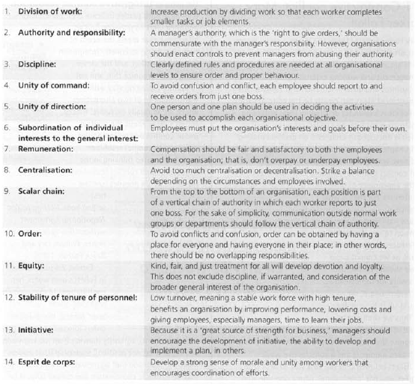

Mary Parker Follett
- Integrative conflict resolution
- Conflict should not be solved by dominance or compromise, but rather through integration
- Making a list of priority wants and needs and developing a new, innovative solution to meet all these where everyone is happy
- Other contributions:
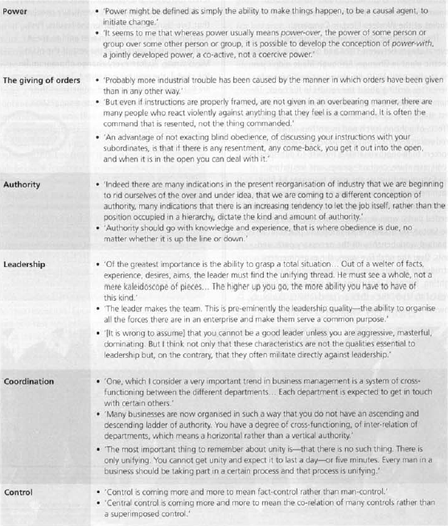

Week 10

Employee development and support
- Four staffing challenges
  - Aligning the workforce with changing requirements
  - Ensuring employee loyalty
  - Monitoring workloads and avoiding burnout
  - Managing work-life balance
- Managing staff needs
  - Evaluating job requirements, descriptions and specifications
  - Forecasting talent and skills needed
  - Forecasting the supply of workers to fill positions
- Diversity is an issue which needs to be addressed
  - Age, race, religion, ability, sex
- Stages of the employment lifecycle
  - Hiring, (working), firing (termination), retiring
- Employee development and evaluation
  - Performance appraisal, some 360 degree crap, electronic performance monitoring, orientation, promotion and re-assignment
- Compensation
  - Wages, incentives, commissions, profit-sharing, pay for performance
- Employee benefits
  - Insurance, retirement benefits, stock options, leave, goods and service discounts, child/elder care assistance, etc.

Labour relations
- Unions
  - Protect the interest of employees – through wages & benefits, working conditions, job security
  - Strength in numbers
Unions =

Week 11

Systems thinking
- Systems view: considers all the steps in a process and closes the loop by providing feedback from the output of one cycle back to the input of the next cycle
- Benefits:
  - Helping everyone see the big picture
  - Understand how individual systems work and interact
  - Understand problems before trying to find solutions
  - Understand the impact of solutions
  - Not just shifting problems around
  - Understanding feedback
  - Using mistakes as chances to improve

Laws of systems thinking
- Solutions cannot afford to be straightforward and simple
- Today’s problems come from yesterday’s solutions
  - Pushing a problem on does not solve the problem
- The harder you push, the harder the system pushes back
  - Cut funding in one place, it will affect the entire operation
- Behaviour gets better before it gets worse
- The easy way out usually leads back
- The cure can be worse than the disease
  - Bringing in someone else to help doesn’t train us to solve problems
- Diving an elephant in half does not produce two elephants
  - Splitting problems won’t address them

Tutorial tips

Tutorial tips

Structuring arguments
- Topic or main sentence
- Supporting sentences
  - Expand the idea and provide evidence
- Acknowledging a counter-argument and refuting (if necessary)
  - Why did you not choose option B
- Concluding sentence (may not be needed)

Summaries and paraphrases
- Summary
  - Rewriting the key points of a text as concisely as possible
  - Detail may not be needed
- Paraphrase
  - Rewrite information in your own words without changing the meaning
  - Needs to be substantially different to the original

Parallel structure
- Use parallel structure when comparing things
  - Similar layout or structure if necessary

Analysing a question
- Use the 5 W’s and the H to ask questions around the scenario
- de Bono’s thinking hats
  - Facts - white
  - Feelings – red
  - Benefits – yellow
  - Downsides – black
  - Creativity – green
  - Justifying your solution – blue
- Task/topic/limit
  - Task – what do I have to do (state/describe/explain/illustrate with example)
  - Topic – topic
  - Limit – any limiting factors (one example, New Zealand, TBL only)
- How many parts to the question are there?
  - Answer all of them

Short answers
- Analyse the question clearly
- Keep the answers clear and concise
- Jot down any key words, ideas and phrases
- Logical structure
- Don’t go off-topic

Analysing
- Strengths and weaknesses of an option
- What are the consequences if your action is not taken?
- What are some possible downfalls and how can they be overcome?
- In-depth description and discussion
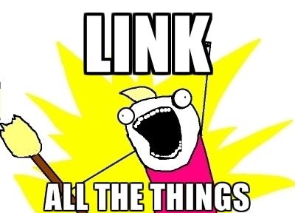

General advice
- Spend 2 minutes per answer preparing
- Plan this out during reading time

Structural words (these help the markers a lot and can increase marks)
- Introduction
  - The topic/issue
- Giving example
  - For example, such as, one reason is, can be illustrated by
- Comparing/contrasting
  - Both, and, more, similarly
  - However, but, although
- Addition information
  - Also, additionally, moreover
- Cause and effect
  - Due to, because, consequently, the reason, since

- Interpreting data / referencing a reading
  - As shown in, according to, as a result of
- Conclusion
  - In conclusion, therefore, these points lead to, according, to summarise

Generally important words to try and put into an answer if relevant
- Manager
- Risk
- Profit
- Success
- Failure
- Decision
- Advantage
- Competition
- Business (you’d be surprised how many people don’t relate their answer to businesses)
- Customer
- Market
- Innovate
- Value
- Creation
  - You get the idea…

Process

Process

Academic integrity
- Academic integrity is important. Don’t plagiarise, reference things properly. Kthxbai

Reports
- Executive summary covers the entire report, including a summary of findings/
conclusions/recommendations
- Introduction presents the topic and what you will discuss
- Body paragraphs - discussion
- Conclusion
- Recommendations
- Reference list

360 reviews
- Are common in the business world
- Be specific, provide examples
- Provide constructive criticism
- Don’t attack people personally
- About contribution to the group, not personality
- Yawn, blah.

Peer review
- Not really important I don’t think
- But be specific, just give good feedback
- Don’t be rude and insult people

Research annotations
- Referencing the source
- Explain how you found the source
- Summarise the main point of the source in a sentence or two
- Explain why the source was helpful for you

Exam advice

Exam advice
- Watch the webcast, I can’t be bothered repeating it.
- Don’t have a panic attack

