Accounting 102:
Financial Reporting Enviroment
FRA – Financial Reporting Act (The old way)
FRB – Financial Reporting Bill (The new way)

IASB – International Accounts Standard Board (The overseas people that decide standards)
IFRS – International Financial Reporting Standards (Created by the IASB)

XRB – NZ External Reporting Board (IASB of NZ)
NZASB – NZ Accounting Standard Board (Committee of the XRB)
FRS – Financial Reporting Standard (Created by the XRB)

New standards (IFRS) are created be the IASB. These are received by the NZASB who make adjustments if necessary before it checked by the XRB and turned into FRS.

GAAP – Generally Accepted Accounting Policies
- Always follow GAAP even if you don’t agree with the amount of disclosure (too much or too little) and disclose the truest views in the footnote
- GAAP costs lots of money to comply with
- If something is not covered by GAAP look for the closest thing and use analogies

Tier 1: Publically accountable (on share market)
Tier 2: $30m revenue and $60m assets

Conceptual Framework
1) Objective:
- Provide information about the reporting entity this is decision useful to present and potential capital providers

2) Definition of elements / recognition criteria

- Assets (Past event… Control of the resource… Probable future economic revenue… Reliably measured…)
- Liabilities (Obligating event which causes present obligation… Probable outflow of resources… Measured reliably… )
- Income (Increase in economic benefits… Which increases net assets… That increases equity which is not capital…)
- Expenses (decrease in economic benefits… Which decreases net assets… That decreases equity which is not drawings…)
- Equity (Owner contributions… Income… Expenses…)

Qualitative characteristics

Enhancing (improve/disprove usefulness)
- Comparability
- Verifiability
- Timeliness
- Understandability

3) Underlying assumptions
Fundamental (makes information decision useful)
- Relevance
  - Materiality
- Faithful representation
  - Complete
  - Neutral
  - Free from error

Explicit – Going concern
Implicit – Periodicity, Monetary unit
Measurement – Historical cost, Fair value, Present values (discounted cash value)
Residual Analysis

Asset
- Is there an economic resource being received?
- Is it being decreased?
- Is anything purchased?

Liability
- Is there a present obligation which has been given rise to?
- Has it been decreased?
- Was the obligation met?

Capital
- Is it from an owner contribution?
- Does net assets change?

Assets 101-199 Liabilities 200-299 Equity 300-399 Revenue 400-499 Expenses 500-599

The liability unearned cleaning revenue has decreased (decrease to liability) as they have met some of its obligation to the shopping centre. The shopping centre had paid cash in advanced which created a present obligation (initial event creating obligating liability) to provide services for this amount which created a probable future economic outflow of resources (wages or using of supplies) that they would use to meet its obligation to the shopping centre. As no asset is affected by the decrease in liabilities this creates an increase to net assets resulting in an increase to equity. As there is no owner contribution, the increase to equity was caused by recognizing income, in this case by increasing cleaning revenue.

Adjusting Entries – events are not recorded daily because it is inefficient to do so adjusting entries are needed eg. depreciation
At the end of the month revenue of $200 earned but not yet received
Date | Account Titles |  | Ref | Debit | Credit
 | Commission Revenue |  |  | 200
 |  | Commission Receivable |  |  | 200

At the end of the month $100 interest is owed but not yet paid
Date | Account Titles |  | Ref | Debit | Credit
 | Interest Expense |  |  | 100
 |  | Interest payable |  |  | 100

Closing Entries
Temporary accounts
- All income (including gains on sale) [closed to income summary]
- All expenses [closed to income summary]

- Income summary [closed to retained earnings]
- Dividends [closed to retained earnings]

There are no temporary accounts in the post-closing trial balance – just assets and liabilties
Income summary and retained earnings have a credit balance when profits are made
If correcting entries are done after closing, retained earnings is used
Inventory
Purchases: Record inventory coming in, 15,000 excluding GST: (if buyer pays freight it counts as cost of inventory)

Date | Account Titles |  | Ref | Debit | Credit
 | Merchandise Inventory |  |  | 15,000
 | GST Clearing |  |  | 2,250
 |  | Cash/Accounts Payable |  |  | 17,250

Paying for $17,250 worth of inventory on terms 2/7 n/30 within 7 days

Date | Account Titles |  | Ref | Debit | Credit
 | Accounts Payable |  |  | 17,250
 |  | Cash |  |  | 16,905
 |  | Merchandise Inventory |  |  | 300
 |  | GST Clearning |  |  | 45

Pay after 7 days

Date | Account Titles |  | Ref | Debit | Credit
 | Accounts Payable |  |  | 15,000
 |  | Cash |  |  | 15,000

Purchase returns for ‘credit’

Date | Account Titles |  | Ref | Debit | Credit
 | Accounts Payable |  |  | 17,250
 |  | GST Clearing |  |  | 2,250
 |  | Merchandise inventory |  |  | 15,000

Sales: Selling inventory costing $17,250 for $25,300 including GST with a perpetual inventory system

Date | Account Titles |  | Ref | Debit | Credit
 | Accounts Receivable |  |  | 25,300
 |  | Sales |  |  | 22,000
 |  | GST Clearing |  |  | 3,300
 | Cost of goods sold |  |  | 17,250
 |  | Merchandise inventory |  |  | 17,250

Receiving cash for sales worth $25,300 including GST in 2/7

Date | Account Titles |  | Ref | Debit | Credit
 | Cash |  |  | 24,794
 | Sales discount |  |  | 440
 | GST Clearing |  |  | 66
 |  | Accounts Receivable |  |  | 25,300

Seller returns everything

Date | Account Titles |  | Ref | Debit | Credit
 | Sales returns and allowances |  |  | 25,300
 | GST Clearing |  |  |  | 22,000
 |  | Accounts Receivable |  |  | 3,300
 | Merchandise inventory |  |  | 17,250
 |  | Cost of goods sold |  |  | 17,250
Counting ending inventory
- FOB shipping point – when it is picked up from courier, ownership transferred
- FOB destination – ownership transferred when goods reach buyer
- Consigned goods – holding goods (being the consignee) to sell but not having ownership

Inventory costing
- Specific identification – only if each is unique
- FIFO
- WAC
  - Valued at the lower of cost or net realisable value
  - Inventory write-down:

Date | Account Titles |  | Ref | Debit | Credit
 | Inventory write-down expense |  |  | 300
 |  | Inventory |  |  | 300

Internal Control and Bank Reconciliation
Internal control
- Safeguard assets
- Enhance accuracy and reliability of accounting records
- Increase efficiency of operations
- Ensure compliance with law and regulations

Petty Cash

Establishing:

Date | Account Titles |  | Ref | Debit | Credit
 | Petty Cash |  |  | 100
 |  | Cash |  |  | 100

Top up fund and record expenses (at this stage there was only $13 left)

Date | Account Titles |  | Ref | Debit | Credit
 | Postage expense |  |  | 44
 | Freight out |  |  | 38
 | Misc expense |  |  | 5
 |  | Cash |  |  | 87

Cash shortage or overage (at this stage there was only $12 left)

Date | Account Titles |  | Ref | Debit | Credit
 | Postage expense |  |  | 44
 | Freight out |  |  | 38
 | Misc expense |  |  | 5
 | Cash over and short |  |  | 1
 |  | Cash |  |  | 88

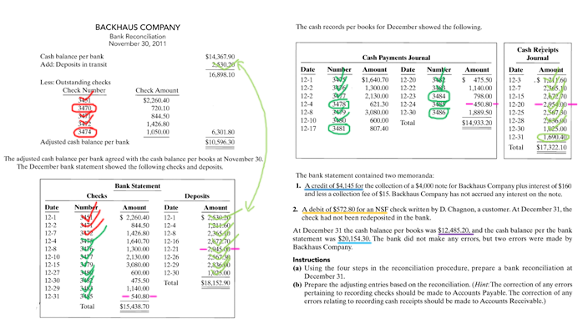
Bank Reconciliation

BACKHAUS COMPANY
Bank Reconciliation
December 31, 2011

Cash balance per bank statement $20,154.30
Add: Deposits in transit 1,690.40
21,844.70
Less: Outstanding cheques
No. 3470 $ 720.10
No. 3474 1,050.00
No. 3478 621.30
No. 3481 807.40
No. 3484 798.00
No. 3486 1,889.50 5,886.30
Adjusted cash balance per bank $15,958.40

Cash balance per books prior to posting JEs $12,485.20
Add: Note collected by bank
($4,000 note plus $160 interest
less $15 fee) 4,145.00
16,630.20
Less: NSF check $ 572.80
Error in recording cheque No. 3485 90.00*
Error in 12-21 deposit
($2,954 – $2,945) 9.00 671.80
Cash balance per books after posting JEs $15,958.40

*$540.80 – $450.80

Receivables
Direct write-off method (not allowed)

Date | Account Titles |  | Ref | Debit | Credit
 | Bad debts |  |  | 200
 |  | Accounts Receivable |  |  | 200

Allowance Method

Problem:
Year 1 Accounts receivable balance $238,500, Estimated doubtful debts percentage 2%
Year 2: Credit sales $100,000, Collections $68,500, Write-offs $4,000, recovery of write-off $500

- Year one adjustment (238,500 x 0.02). [allowance is a contra account, not a liability]
Date | Account Titles |  | Ref | Debit | Credit
 | Bad debts |  |  | 4,770
 |  | Allowance for doubtful accounts |  |  | 4,770

- Year two sales and collections
Date | Account Titles |  | Ref | Debit | Credit
 | Accounts Receivable |  |  | 100,000
 |  | Sales |  |  | 100,000
 | Cash |  |  | 68,500
 |  | Accounts Receivable |  |  | 68,500

- Accounts receivable balance at year end: 238,000 + 100,000 – 68,500 = $270,000

- Year two write off
Date | Account Titles |  | Ref | Debit | Credit
 | Allowance for doubtful accounts |  |  | 4,000
 |  | Accounts receivable |  |  | 4,000

- Recovery of write-off
Date | Account Titles |  | Ref | Debit | Credit
 | Accounts Receivable |  |  | 500
 |  | Allowance for doubtful accounts |  |  | 500
 | Cash |  |  | 500
 |  | Accounts Receivable |  |  | 500

- Accounts receivable balance after write-offs: 270,000 + 500 – 4,000 – 500 = $266,000

- Work out Allowance account balance: 4,000 – 4,770 – 500 = $1,270

- Work out how much is needed in allowance account: 266,000 x 0.02 = $5,320

- Subtract balance needed from actual balance 5,320 – 1,270 = $4,050

- Record bad debt write-off
Date | Account Titles |  | Ref | Debit | Credit
 | Bad debt expense |  |  | 4,050
 |  | Allowance for doubtful accounts |  |  | 4,050

- Showing depreciation on balance sheet
Accounts Receivable $266,000
Less allowance for doubtful debts (5,320)
260,680

Credit Card Sales – inventory sold for $10k, 3k of it was cash, 2.2k credit and 4.8k credit card with 3% service fee

Date | Account Titles |  | Ref | Debit | Credit
 | Cash |  |  | 7,656
 | Credit card service expense |  |  | 144
 | Accounts Receivable |  |  | 2,200
 |  | Sales |  |  | 10,000

Notes:
- Must have a promissory note, if not it goes to accounts receivable

Accepted $16,000, 3-month, 9% not for balance due

Date | Account Titles |  | Ref | Debit | Credit
 | Note Receivable |  |  | 16,000
 |  | Accounts Receivable |  |  | 16,000

Collected note in full (16,000 x 0.09 / 12 x 3) = 360

Date | Account Titles |  | Ref | Debit | Credit
 | Cash |  |  | 16,360
 |  | Notes Receivable |  |  | 16,000
 |  | Interest revenue |  |  | 360

Note dishonoured but still expecting payment

Date | Account Titles |  | Ref | Debit | Credit
 | Accounts Receivable |  |  | 16,360
 |  | Notes Receivable |  |  | 16,000
 |  | Interest revenue |  |  | 360

Property, Plant and Equipment and intangible assets
What do we capitalise initially?
- All costs directly related to bringing the asset to the location in necessary condition to be used.
- If its dropped the cost to repair is an expense
Land
- Purchase price
- Closing costs (title, attorney’s fees, real estate brokers commissions)
- Cost of grading, filing, draining and clearing
- Paying off any previous costs owed on the property

Land improvements (can be depreciated)
- Driveways, parking lots, fences
Buildings
- Purchase price and closing costs
- Remodelling and replacing roof/floors/electrics/plumbing
- Construction costs + architects fees, building permits and evacuation costs
- Interest on debt incurred while building

Equipment (not training or repairs due to negligence)
- Purchase price
- Freight and handling charges + insurance
- Assembling, insurance and installation costs
- Cost of trial runs

Depreciation
- Start when it is ready for intended use
- Finish when no value left, hit residual value, dispose of it or reclassify

Straight line per year = $\frac{cost-residual value}{usefull life}$

Declining balance for the year = $book value x double straight line right$(RESIDUAL NOT DEDUCTED)

Units of Activity $\frac{(Cost-residual value) x units expected in the year}{total units of activity over lifetime}$

Revaluation
- Huge costs to revalue, inconsistency in accounting – gains and losses go different places, increases deprecation amount leading to less profits unless they want to increase debt ratios
- Gains on revaluation goes to other comprehensive income IF there was previously an unrecovered loss the gain goes to other income and expenses and any extra goes to other comprehensive income.
- Losses go to other income and expenses and IF there was a previous gain same applies

Disposals
- Record depreciation for the year
- Add it to total accumulated depreciation and subtract this from asset cost
- Work out the difference between selling price and carrying amount and record gain or loss on sale

Date | Account Titles |  | Ref | Debit | Credit
 | Cash |  |  | 25,000
 | Accumulated Depreciation |  |  | 17,500
 |  | Gain on sale |  |  | 7,500
 |  | Asset |  |  | 35,000

Intangible assets
- No physical substance, non-monetary and non-current
- Patents, franchises, trademarks, copyrights, software (intangible if purchased or PPE if developed), goodwill (can only be obtained when buying a business)
- Research and Development costs are expensed until the asset is technically feasible
- Intangible assets are amortised using straight-line depreciation if it has a definite useful life

Liabilities
- Legal: Litigation (when we get sued), Legislation (tax)

Bonds/Debentures
- Represents a promise to pay face value of bond at maturity date
- Plus periodic interest rate
- Generally used when they want capital from more than one lender (heaps)
- Yield is market interest rate
  - At market rate is face value
  - Less than is Premium
  - Higher than is Discount
  - Needs to be amortised to get it up/down to market rate (obligation decreases over time)
Advantages
- Shareholder control not affected (might want to keep voting %)
- Tax saving (interest is tax deductible)
- Increase financial leverage (net profit – dividends/number of shares) [no. of shares doesn’t increase]

Issuing 1000 9%, 5 year $1,000 bonds. Interest paid every six months

Date | Account Titles |  | Ref | Debit | Credit
 | Cash |  |  | 1,000,000
 |  | Bonds Payable |  |  | 1,000,000

Recording interest after 6 months (1,000,000 x 0.09 x 6/12)

Date | Account Titles |  | Ref | Debit | Credit
 | Bonds Interest expense |  |  | 45,000
 |  | Cash |  |  | 45,000

Record interest payment with amortisation – Issues $100,000 of 10% five year bonds on Jan 1, 2011 for $92,639 with interest payable on July and Jan 1 with an effective yield of 12%
- 92,639 x 0.12 x 0.5 b) 100,000 x 0.1 x 0.5 c) a-b

Date | Account Titles |  | Ref | Debit | Credit
a | Bonds Interest Expense |  |  | 5,558
b |  | Cash/Bonds interest payable |  |  | 5,000
c |  | Bonds Payable |  |  | 588

Redeeming bonds before maturity date (redeemed after interest payment) – Retires bonds at 103 with carrying amount of $101,623

Date | Account Titles |  | Ref | Debit | Credit
 | Bonds payable |  |  | 101,623
 | Loss on bond redemption |  |  | 1,377
 |  | Cash |  |  | 103,000

Instalment Loans – single lender, promissory note, equal periodic payments

Borrowed $449,550 with $10,000 repayable at the end of each month, interest rate 12%
- Interest is 449,500 x 0.12 / 12. Loan principle is the rest.

Date | Account Titles |  | Ref | Debit | Credit
 | Interest expense |  |  | 4,496
 | Loan payable |  |  | 5,504
 |  | Cash |  |  | 10,000
Warranties
- Are provisions because of uncertainty of how much they will cost
- Set up warranty for $70,000, $65,000 of repairs, expected $75,000 for next year.

Setting up the warranty provision

Date | Account Titles |  | Ref | Debit | Credit
 | Warranty expense |  |  | 70,000
 |  | Warranty provision |  |  | 70,000

Record repairs

Date | Account Titles |  | Ref | Debit | Credit
 | Warranty provision |  |  | 65,000
 |  | Parts inventory |  |  | 30,000
 |  | Wages payable |  |  | 35,000

$70,000 begging - $65,000 for repairs = $5,000 remaining. Repeat first entry to get to $75,000 in provisions

Provisions
- Are distinguished from other liabilities because of their uncertain settlement
- A probable obligation is sufficient for present obligation

Contingent Liabilities
- Only a possible obligation so not on the balance sheet (more uncertain)

Payroll – earned wages of $70,000 with a bunch of fees and stuff

Date | Account Titles |  | Ref | Debit | Credit
 | Wages expense |  |  | 70,000
 |  | PAYE Payable |  |  | 5,000
 |  | Union Fees Payable |  |  | 500
 |  | Wages payable |  |  | 64,500

Equity
- Sole trader only has one equity account
- Company has at least ordinary shares and retained earnings

Contributed equity
- Ordinary shares
- Preference shares – gets priority in liquidation
  - Cumulative – when a dividend is not declared it gets accrued so they receive that and the next years shares when they finally pay a dividends
  - Non-cumulative – (not as common) – don’t get accrued dividends
- Treasury shares – shares company has bought back for themselves and not retired (not an asset)
    - Recorded after retained earnings as “less treasury shares”
  - For employee bonuses
  - Use for buying companies with shares
  - Increase earnings per share by removing shares from the market

Reserves
- Retained earnings
- Other reserves
  - Voluntary reserves – using retained earnings for expansion
  - Involuntary reserves – due to accounting standard (revaluation)

Raising share capital
- Private placement – insurance companies/banks
- Public issuance – requires prospectus (cost of creating prospectus comes out of share capital)

Receiving money from public issue by application

Date | Account Titles |  | Ref | Debit | Credit
 | Cash Trust |  |  | 45,000
 |  | Application |  |  | 45,000

Entry on issue of shares – if oversubscribed just refund

Date | Account Titles |  | Ref | Debit | Credit
 | Cash |  |  | 45,000
 | Application |  |  | 45,000
 |  | Cash trust |  |  | 45,000
 |  | Share capital |  |  | 45,000

Buying back shares – 4,000 shares at $8 per share

Date | Account Titles |  | Ref | Debit | Credit
 | Treasury |  |  | 32,000
 |  | Cash |  |  | 32,000

Sells 10,000 treasury shares for $10 each (bought for $8)

Date | Account Titles |  | Ref | Debit | Credit
 | Cash |  |  | 10,000
 |  | Treasury shares |  |  | 8,000
 |  | Share capital |  |  | 2,000

Dividends – DO NOT GO IN THE BALANCE SHEET
- Must pass solvency test before and after dividend paid
  - Liquidity test
  - Solvency test (assets are greater than liabilities including contingent liabilities)
- Preferred get paid first, the rest if any goes to common. If there is not enough for preferred it accrues to the next year.

Share dividends
- Issues shares instead of a cash dividend
- Capitalises retained earnings, reduce market price of share
- Give shareholders something when you don’t want to pay cash

Declares 10% share issue. Has 200,000, $10 common shares

Date | Account Titles |  | Ref | Debit | Credit
 | Dividends |  |  | 240,000
 |  | Share dividends distributable |  |  | 240,000

Issues share dividend

Date | Account Titles |  | Ref | Debit | Credit
 | Share dividends distributable |  |  | 240,000
 |  | Share capital |  |  | 240,000
Share splits
- Issuing more shares to current shareholders
- Reduces market price of shares
- No journal entry, just increases the number of shares (but disclosed on footnote)

Events that affect comparability

Quality: A faithful representation
- Prior period errors
  - Mathematical mistakes
  - Mistakes in application of accounting policies (capitalise instead of expense)
  - Oversight or misuse of facts
    - Correct with journal entry when discovered
    - Redo all statements with fix (error in footnotes)

Sustainability: What part of the profit will recur?
- Discontinued operations
  - Must be clearly distinguishable and cash generating component
  - Must be a separate major line of business or geographical area

Profit from continuing operations (previously net profit)
Discontinued operations
Profit/Loss on operations, net of tax xx
Gain/Loss on sale, net of tax xx
Total gain/loss on discontinued operations xx
Net profit xx

More Bank Rec

Per bank statement
- Adjustments to the bank balance
  - + deposit in transit
  - – outstanding cheques
  - +/- Bank errors

Per books
- Adjustments to the book balance
  - + notes collected
  - – NSF cheques
  - – cheque printing or other service charges
  - +/- company errors

Errors: If book value is higher than bank value for deposit, subtract from books
If book value is higher than bank value for withdraws, add to books

Ratios
Profitability analysis
$$Gross profit ratio= \frac{Gross profit}{Net sales}$$

$$Operating expense ratio= \frac{Operating expenses}{Net Sales}$$

$$Profit margin ratio= \frac{Net profit}{Net sales}$$

$$Return on assets= \frac{EBIT}{Average assets}$$

$$Earnings per share= \frac{Net profit-dividends}{Number of shares}$$

Accounts Receivable analysis
$$Accounts Receivable turnover = \frac{Net Credit Sales}{Average Gross Accounts Receivable} (Allowance not deducted)$$

$Average collection period= \frac{365}{Accounts Receivable turnover}$

Inventory turnover analysis
$$Inventory turnover= \frac{Cost of goods sold}{Average inventory}$$

$Days in Inventory= \frac{365}{Average inventory}$
High inventory levels may lead to high carrying costs (storage, insurance, damage)
Low inventory levels may lead to stock outs

Short term financial risk analysis
$$Current ratio= \frac{Current Assets}{Current Liabilities}$$

$Acid Test ratio= \frac{Cash+short term investments+Receivables (net)}{Current Liabilities}$ (Receivables less allowance)

Solvency ratios
$$Debt to total assets= \frac{Total debt}{Total assets}$$

$$Times interest earned= \frac{EBIT from continuing operations}{Interest expense}$$

Equity ratios

$$Return on equity= \frac{Profit minus preference dividends (cummulative only this years, non only if declared this year)}{Average common shareholders equity (total equity minus book value of prefered shares)}$$

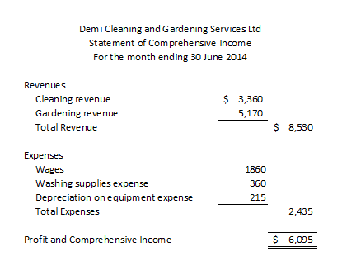
Financial Statements
Statement of Comprehensive Income:

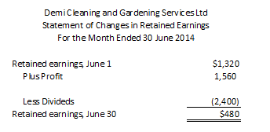
Statement of Changes in Retained Earnings

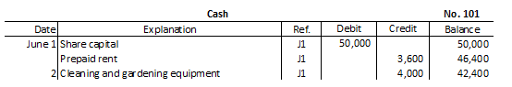
General Ledger - Purpose of a trial balance is to check if it balances after posting

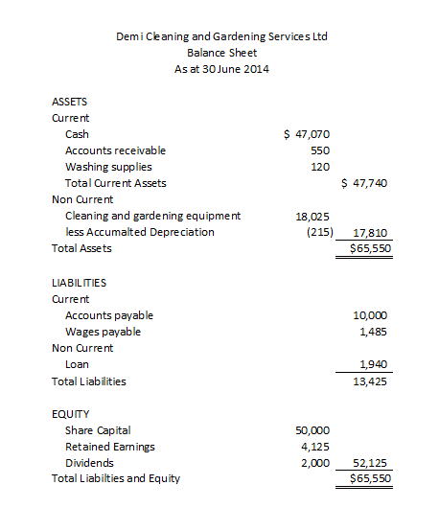
Statement of Financial Statements/Balance Sheet

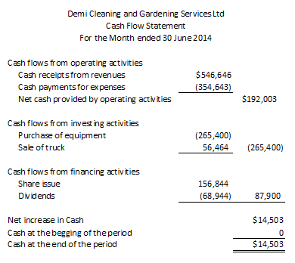
Statement of Cash Flows

