BUSINESS 291: COMMUNICATION THEORY AND PROFESSIONAL PRACTICE:

COMMUNICATION COMPETENCE: the ability to write, speak and generally interact with others effectively
Professionals rely heavily on well-developed communication skills. Good communication is a key competency as well as being a necessity in today’s professional work environment. Communication competence is likely to vary according to the forms of communication we use in professional life. People are different; some thrive on speaking while others prefer conveying messages in writing.

ETHICS IN COMMUNICATION: Ethical communication is fundamental to responsible thinking and decision-making, and the development of relationships and communities within and across cultures, media and society in a broader perspective. Ethics deals with questions of right and wrong, honesty, accuracy of information and integrity and can be defined as a set of principles of right and moral conduct but these can be socially or culturally determined.

Ethical boundaries are usually set up in an organization’s mission statement and by codes of conduct for professional employees. Business ethics are more than just virtue, integrity or character.
COMMUNICATION CODE OF ETHICS:
1. Good communication is clear (using language and other symbols to explain logically and exactly. Avoids vagueness, inaccuracy and distortion of facts)
2. Good communication is honest (presents all necessary and relevant information)
3. Good communication is democratic (should not disadvantage any group ethnically, culturally or gender wise)
4. Good communication is sincere (uses persuasion and advocacy with facts and judgments which do not, either overtly or covertly, appeal to prejudice or ignorance)
5. Good communication respects its audience (It makes its message clear to an understandable language. It is thorough and balanced while avoiding to patronize the audience)
6. Good communication is logical (it does not try to persuade, omit or deceive)
Unethical communication can be dangerous.

DEFINING COMMUNICATION:
1. COMMUNICATION IS THE TRANSMISSION OF MESSAGES: Sender encodes a message it is sent through a mediumdecoded by the receiver
(the medium/”packaging” of the message affects the efficiency of the communication)
2. COMMUNICATION IS SOCIAL INTERACTION THROUGH MESSAGES: Seen as behavior that allows people to relate by interacting or exchanging ideas and experiences to develop understandings. People take turns sending and receiving while all taking responsibility for reaching agreement or understanding and resulting in better relationships between people.
3. COMMUNICATION IS THE RECIPROCAL CREATION OF MEANING IN A CONTEXT: Through language and symbolic forms we generate meaning, we make sense through relating to each other. Begin with different meanings for the same thing and then negotiate a closer understanding (perhaps never agreeing on the meaning of the concept) by narrowing the gap between both ideals. Time, place, emotional atmosphere and culture can all affect meaning.
4. COMMUNICATION IS THE SHARING OF MEANING THROUGH INFORMATION, IDEAS AND FEELINGS: Sharing=intention to contribute, not merely an incidental coming together or interaction. MEANING consists of:
-information (perception of facts such as the coming of rain during the day)
-ideas (concepts, opinions and attributes such as commitment to a safe workplace)
-feelings (love, admiration, distrust, anger)
Messages are constructed (encoded) and interpreted (decoded) by the individual or group. The capacity of people to communicate and build constructive relationships is very limited. Meanings differ from one to another. People should try to NARROW the communication gap as there is no such thing as perfect communication between people.

PURPOSE IN COMMUNICATING: Meaning can be information (perceived facts), ideas (concepts and opinions) and emotions (personal feelings). Thus, we communicate on multiple levels of meaning (emotion), information may be overlaid with opinion, prejudice or bias; our questions about facts may reflect doubts etc…
Most of the time humans communicate without meaning to do so, (e.g. yawning at a seminar shows lack of interest in a non-verbal manner). Purposeful communication involves clear reason to communication and responsibility for doing so, organisation of the message to achieve the intended purpose (clarity), using the best medium to your advantage, tailoring the message to the features of the receiver or the context of the communication and gibing the receiver the opportunity to understand and respond.

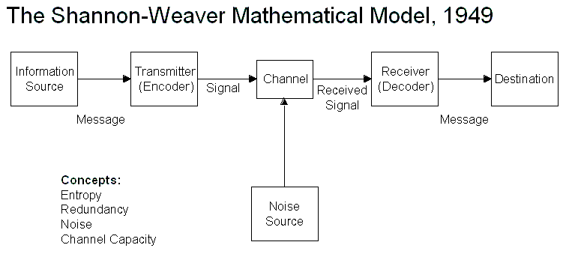
THE TRANSMISSION MODEL OF COMMUNICATION:
-SOURCE AND RECEIVER: Two people exchange information, attitudes and feelings. Each takes it in turn to lead and then follow by swapping facts and figures about the business they run together. Both have different skills and points of view, different needs and approached to business.
-MESSAGE: involved content (basic idea), structure or shape (way the idea or information is ordered) and code(s). Code can be language, pictures, body actions or music.
-MEDIUM/CHANNEL: Choosing the medium is as important as constructing the message. Each medium has its own positives and negatives. Channel refers to the sensory base for conveying, or transmitting messages. The more channels used in a medium, the greater depth of communication is achieved.
-FEEDBACK=RESPONSE to the message. Not all communication required feedback.
-NOISE: any element which interferes with the process of communication. Mechanical noise=physical interference with the signal. Resulting from e.g. poor mobile reception, bad acoustics in a lecture theatre but are easy to detect and control e.g. buying a better phone. Semantic noise {study of the meaning of words}=breakdown of meaning between source and receiver as a result of the misuse or misinterpretation of language; words need to be chosen carefully e.g. not be too technical to avoid confusion. Psychological noise=emotional barriers between parties to the communication occurring from preconceived notions, attitudes, biases or prejudices about the speaker or the message itself. This type of noise may affect how we interpret or understand a message, a person uninterested in sport will not be inspired by a successful sportsperson.
-ENCODING: packaging or translating of an idea into an understandable form which can be communicated.
-DECODING: the interpretation, translation or unpackaging of a message.
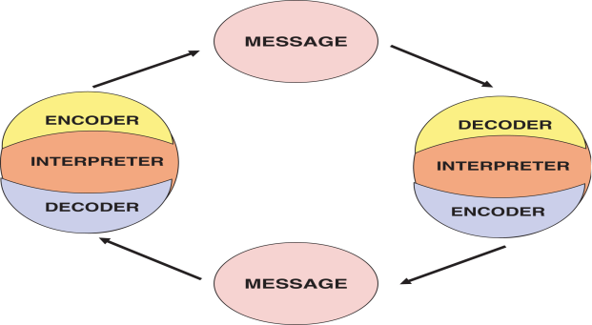
Thus forming an encoding-decoding cycle of feedback.
It is important the source knows the effectiveness of the message, because often it can be out of date, boring, threatening or too technical, or the wrong medium has been used.
Therefore sources and senders should think carefully about the effect they wish to achieve before communicating. They should therefore structure their message carefully, using codes likely to be familiar to the receiver. The choice of channel can be vital to the success of a communication. the elements of skills, attitudes,knowledge,social system and cultural awareness all play a part in the sending and receiving of messages. Overlooking the importance of any one of these elements in the receivers can disrupt communication. Feedback evaluates communication, but the feedback should be sought out as expertly as possible.
NB: sometimes the transactional model focuses too hard on the message and the channel of communication. Critics state you cannot reduce or isolate the elements of a communication situation because communication is essentially about the big picture: greater than a sum of parts.
-Human communication is not mechanical and cannot be broken down to a large extent; a lot of communication is done by non-verbal signal such as body language.

THE TRANSACTIONAL MODEL OF COMMUNICATION:
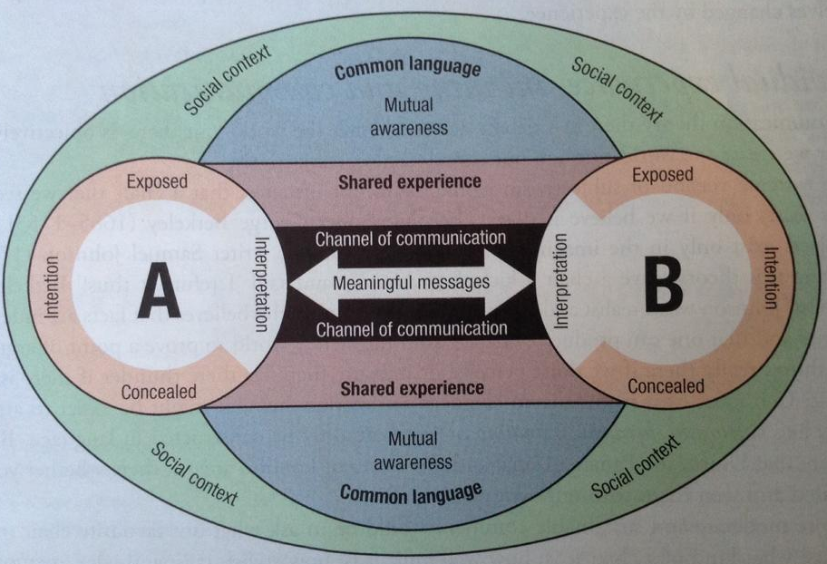
This model views communication as two or more parties responding to a phenomenon or to the environment and brings to it their own set of interpretations and negotiate meaning.
-MEANING: "meanings are in people, not words". Words can mean different things to different people because people interpret things in context/a social situation at a certain time. Outside of any social context, meanings can change by a large margin. Therefore (according to the transactional model) communication is not the flowing from a source to a receiver and back. It is rather, two or more partied responding to a phenomenon/environment and bringing their own interpretations. They NEGOTIATE MEANINGS and are themselves CHANGED by the experience.
-INDIVIDUAL EXPERIENCE, MEANING AND COMMUNICATION: different people take different meaning from the same message.
-THE PERSONAL CONSTRUCTION OF REALITY: people have different opinions about movies (for example) because as humans we all have a different perception of reality. This can sometimes produce gaps in communication. Humans experience the world through (5) sensory nerve endings which form our unique “perceptions”. Perception is important in understanding how humans communicate and make meaning about the world around us.
-THE SOCIAL CONSTRUCTION OF REALITY: Due to all the information in the world people have different experiences from each other, on many occasions this is due to social conditioning which hinders our perceptions.
-FRAMES OF REFERENCE: Our mental set or “frame of reference” may be personal and/or social.
-COMMUNICATING IN SOCIETY: Symbolic interactions define society in terms of a large group having a common culturea similar way of communicating. Our communication reflects the rules of society. Body language {common etiquette}, cultural actions etc…
COMMUNICATION:
CULTURE is dynamic and constantly changing. Communication is affected by one’s membership of a culture, and irreconcilable cultural differences can be a big factor in weakening mutual understanding between groups of people: students, professionals, family members, sporting participants or children.
GENDER: “Gender differentiation” In our society the roles of men and women have always been distinguished and those of women have usually been subordinated. Views on women are different in western and eastern countries.

THE TRANSACTIONAL model foregrounds meaning rather than message: its creation and sharing, its subjectivity and unreliability; and the fact that there is always a gap between meanings attributed to the same phenomena. People create their individual meanings and social groups do the same. We see the world through our own frames. Society is the way we organise our communication, lives and relationships.

TRANSACTION:
CONCENTRATES ON MEANING
Communication is not always predictable and the situation or context in which the communication takes place can impact how parties communicate. Take into account culture and gender.
TRANSMISSION:
Sees communication as the transfer of messages from a source to a receiver, using a channel and medium.
-Uses mechanical terms like source, receiver, feedback and noise
-Very linear. AB
-Puts a huge emphasis on exact content or value of feedback.

